**Assignment A1**

1. Create a directory ‘project_dir’ & cd to ‘project_dir’.

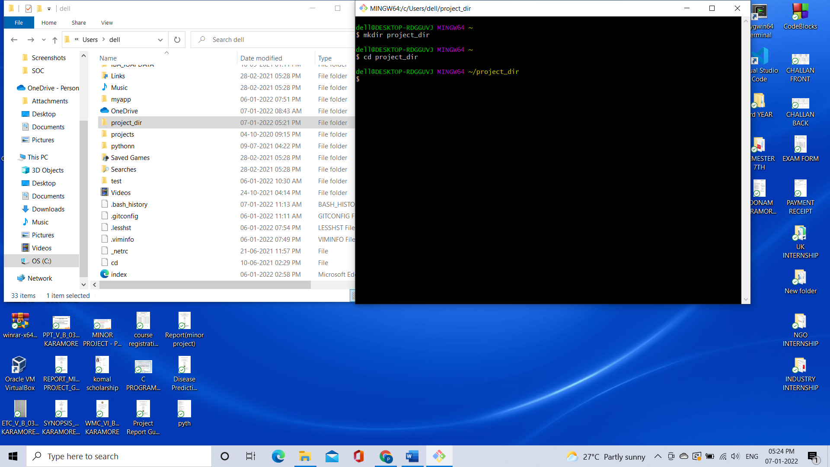

2. Initialize git version database.

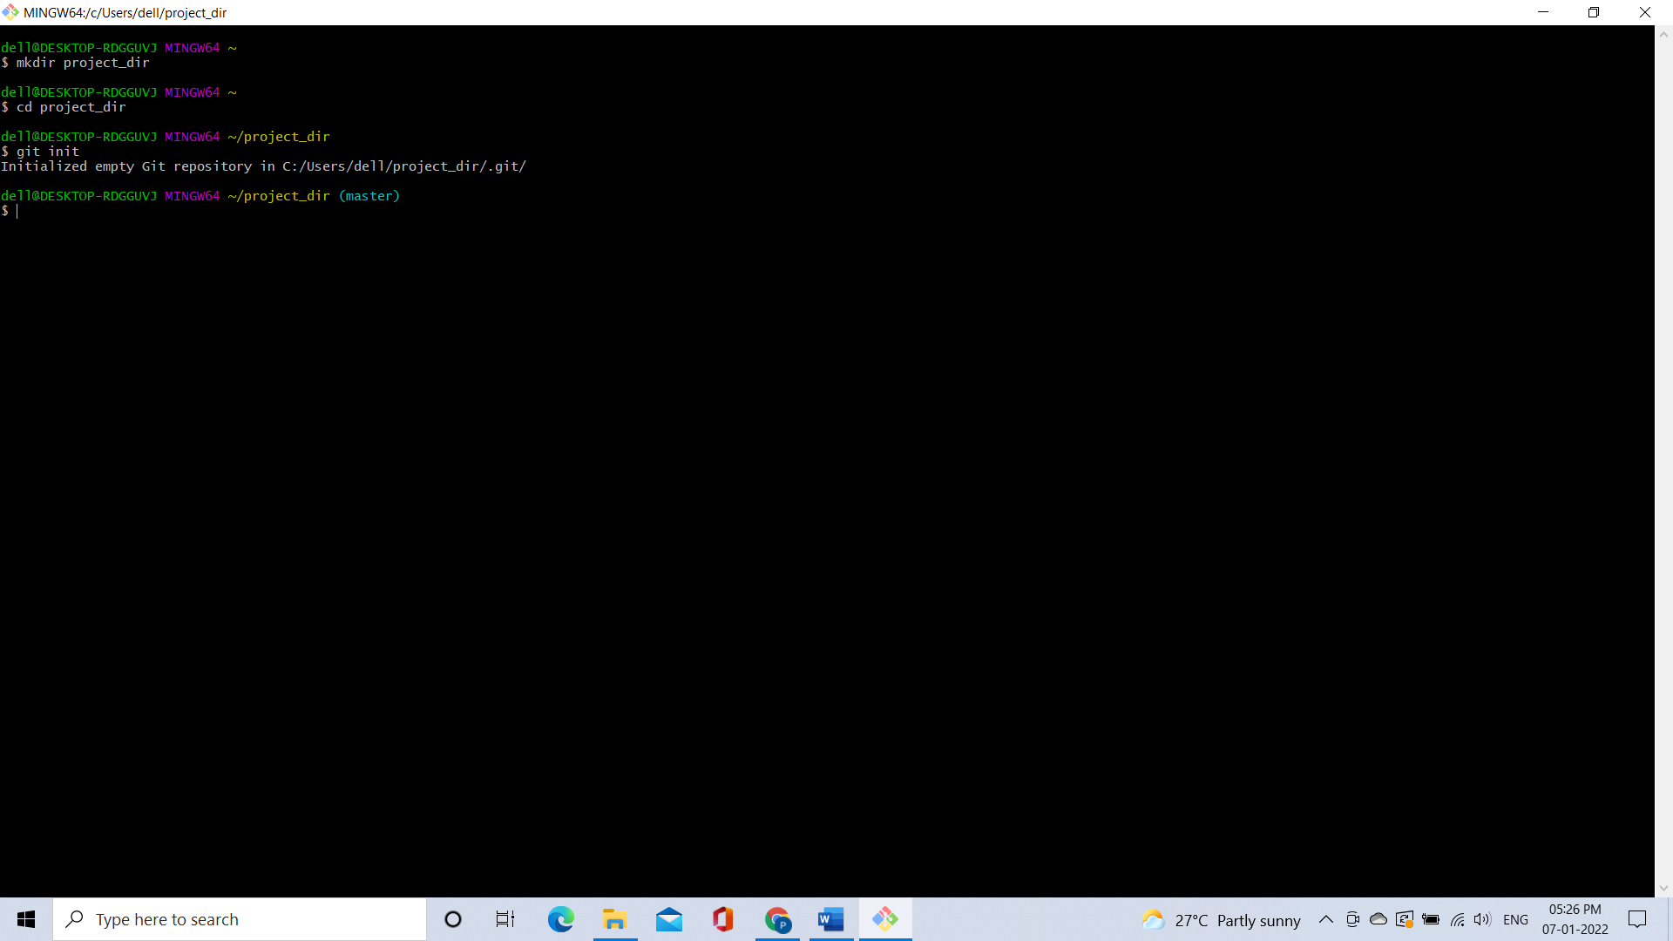

3. Create a new file index.html.

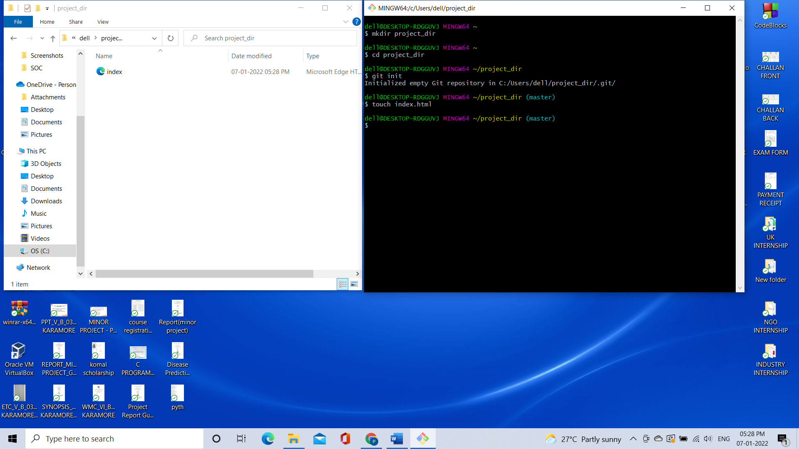

4. Check the git status. You should find index.html as untracked file.

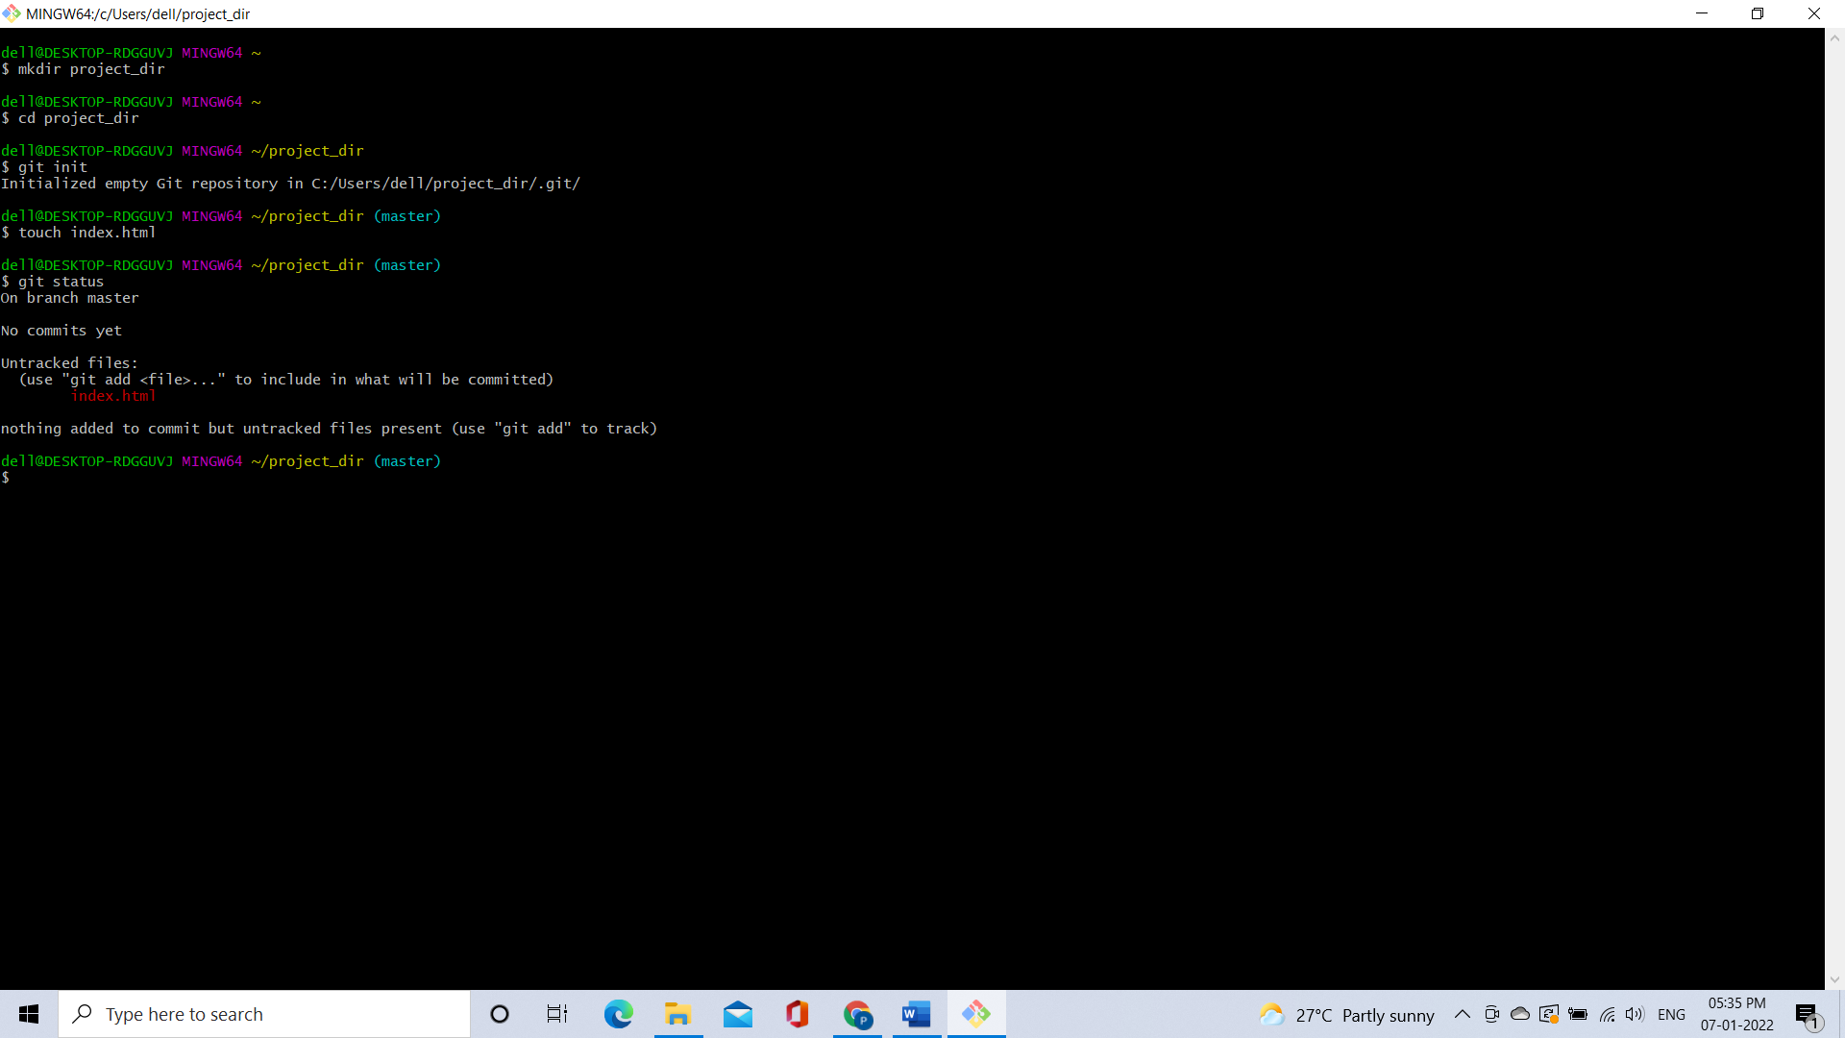

5. Stage the index.html file.

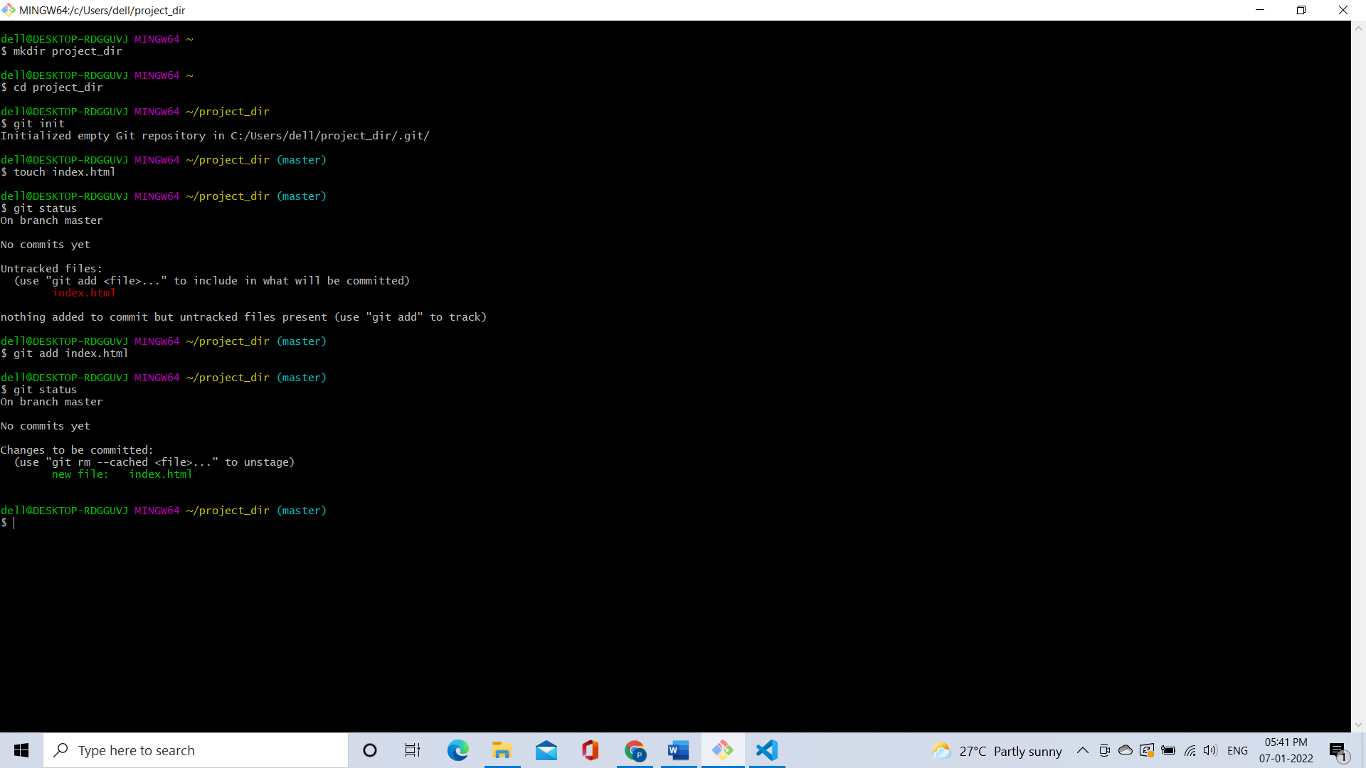

6. Commit index.html

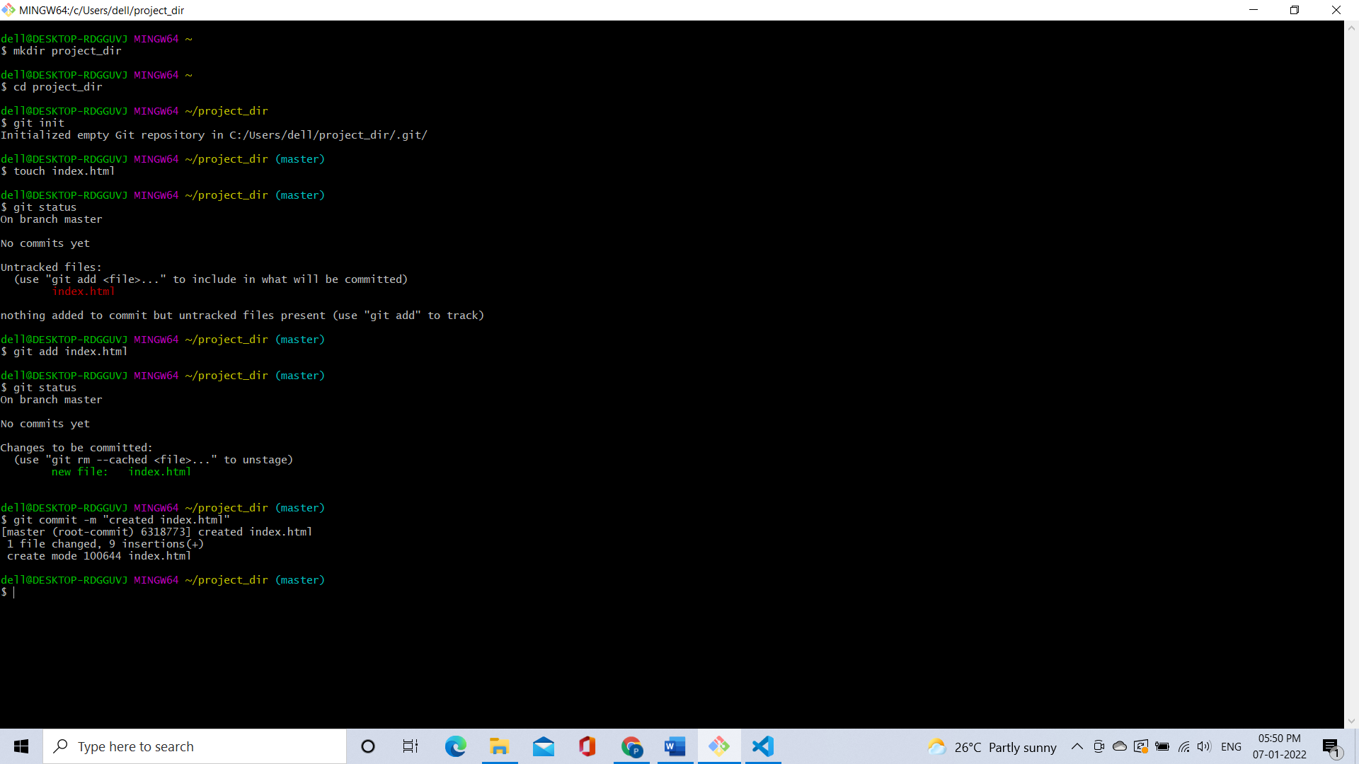

7. Make few changes in index.html & create a new file info.txt file.

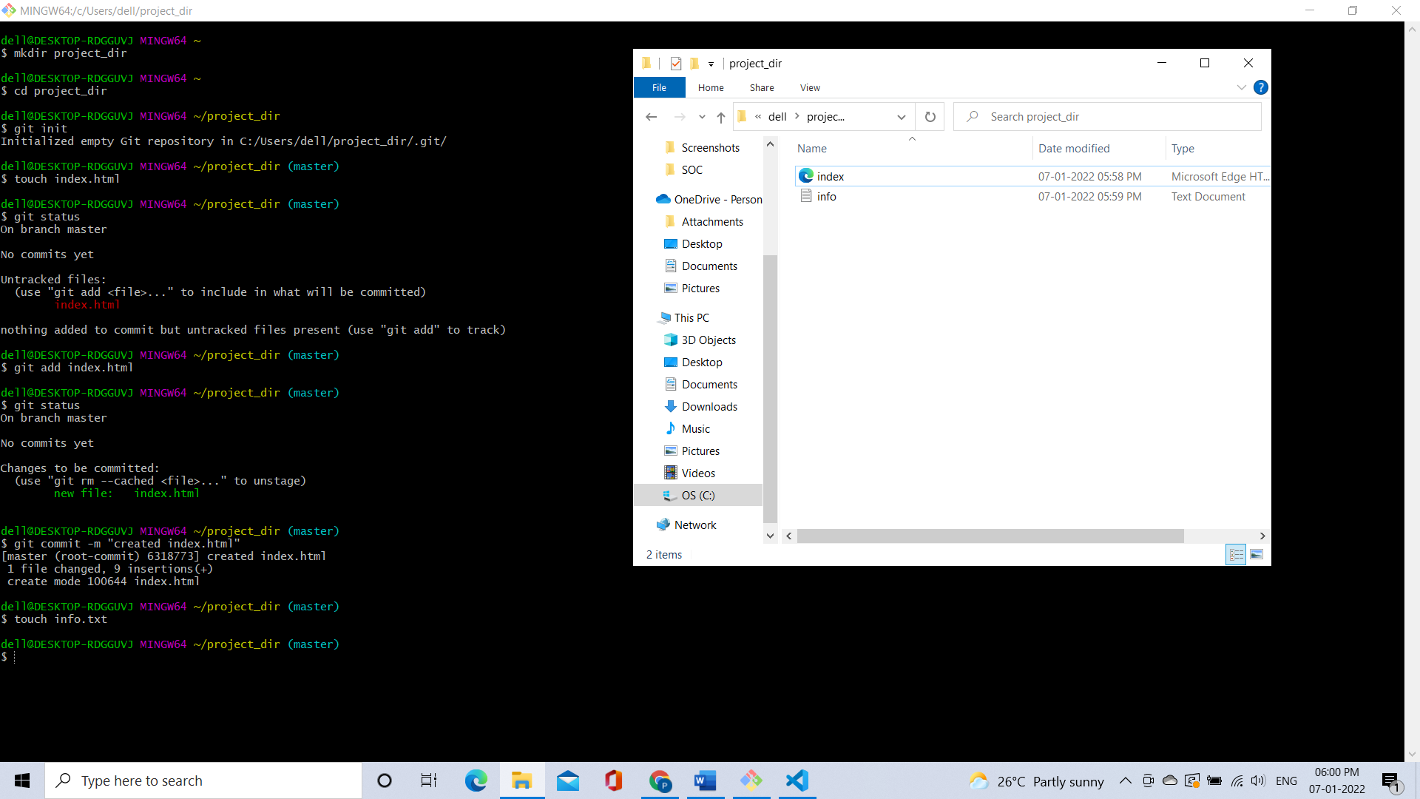

8. Check git status. You should find index.html & info.txt as untracked files.

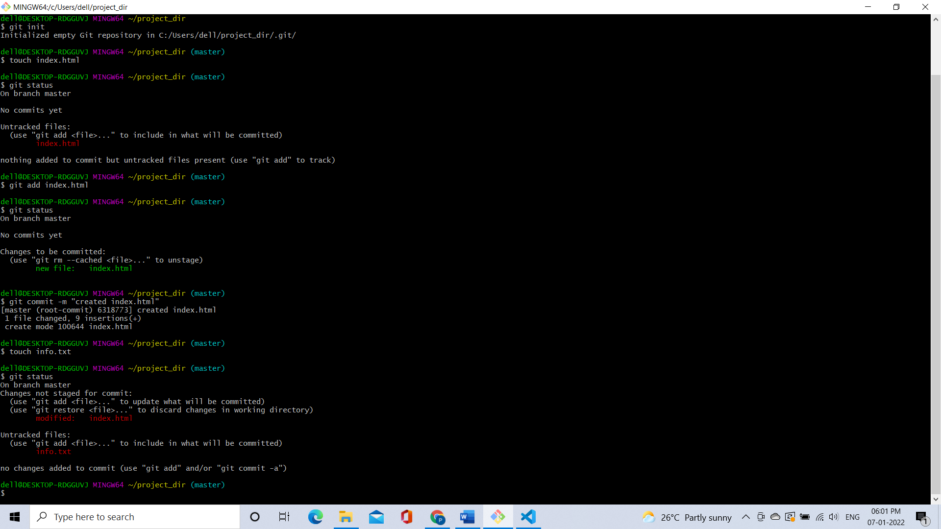

9. Configure GIT to ignore all txt files.

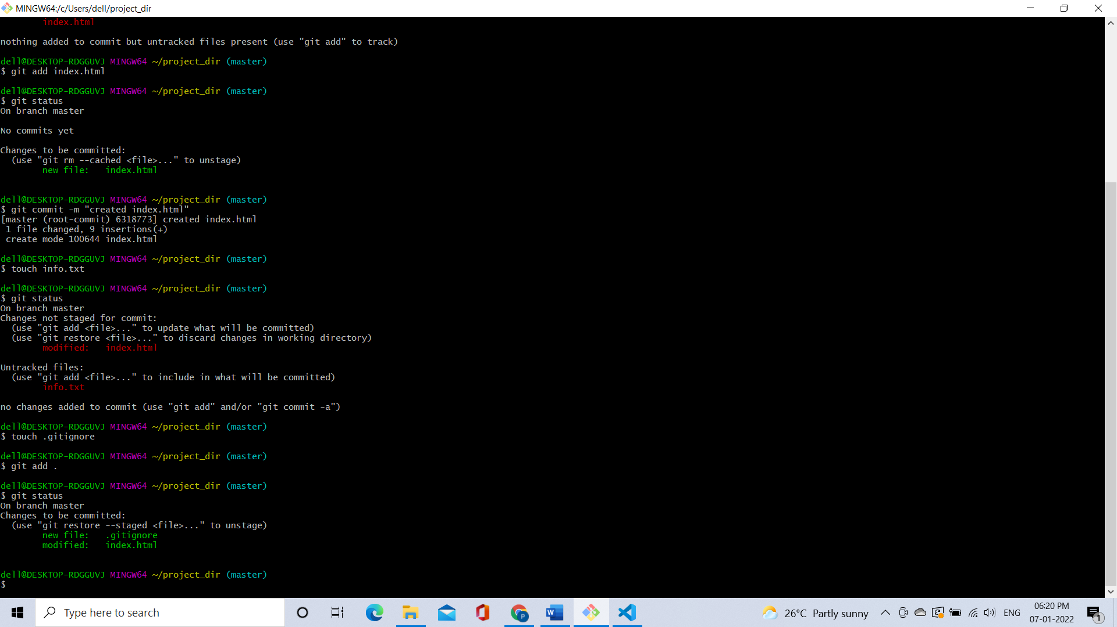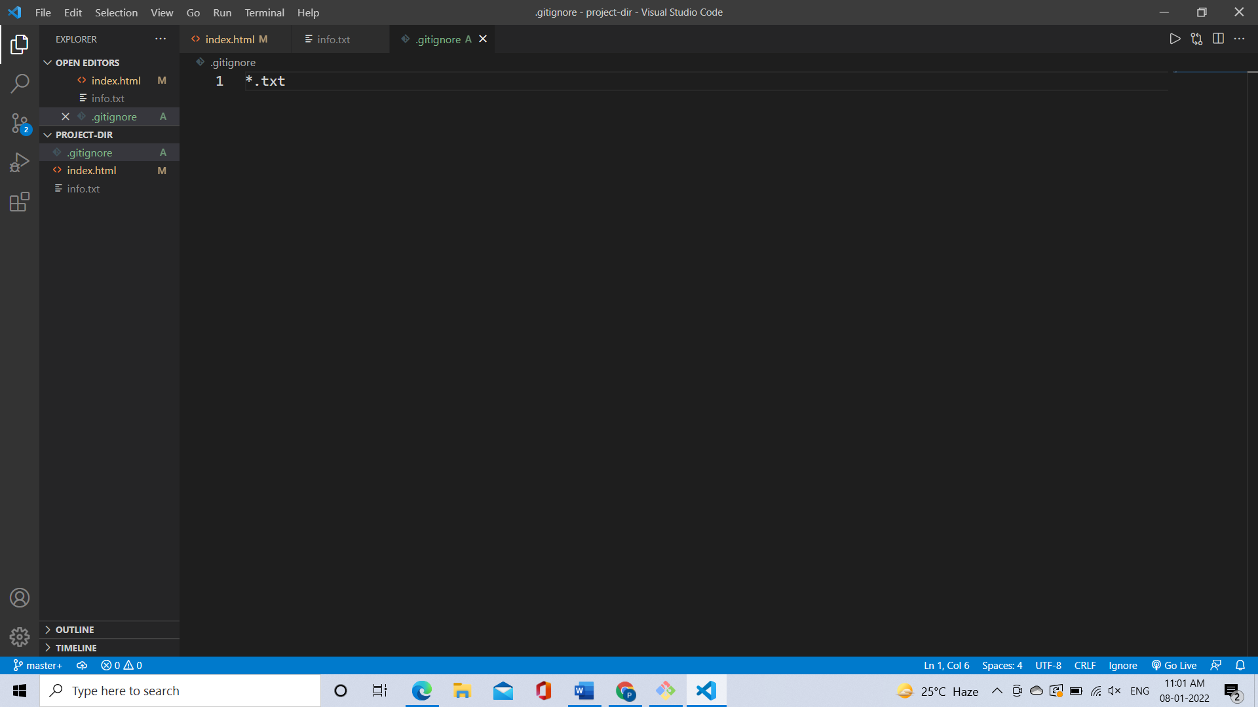

10. Again check the git status. You should find only index.html as untracked file.



11. State & commit index.html

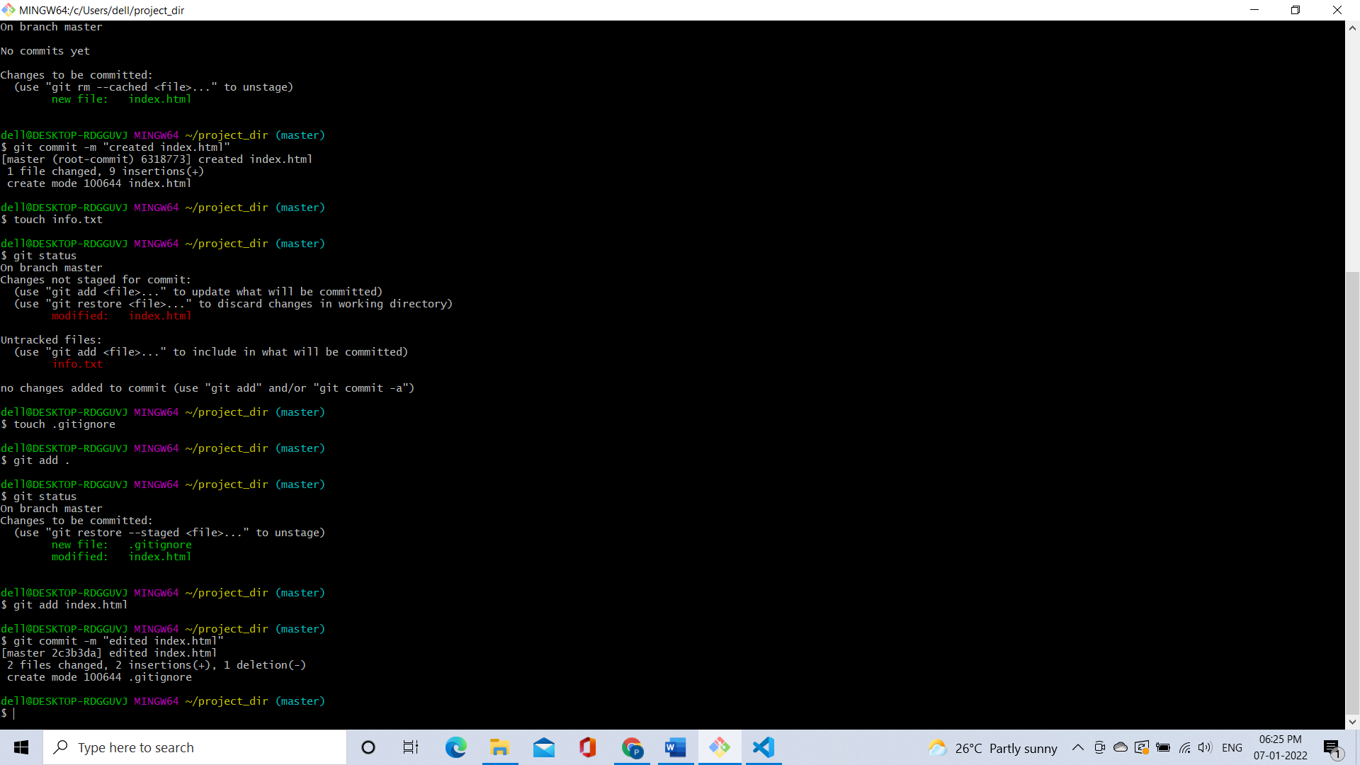

12. Log all your commits so far.

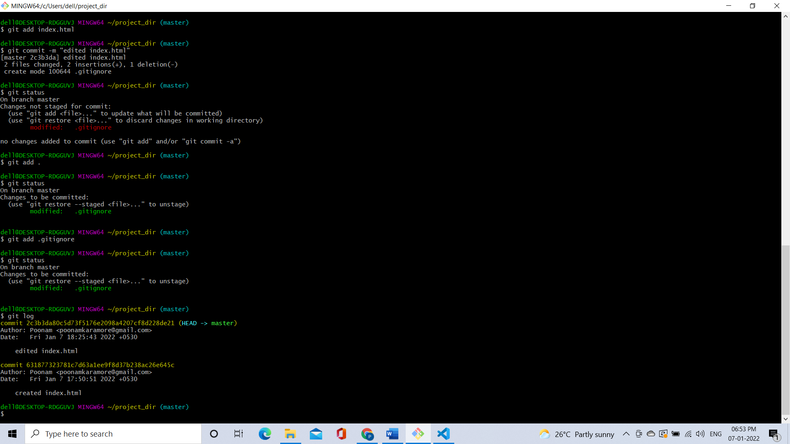

13. Make some changes in index.html.

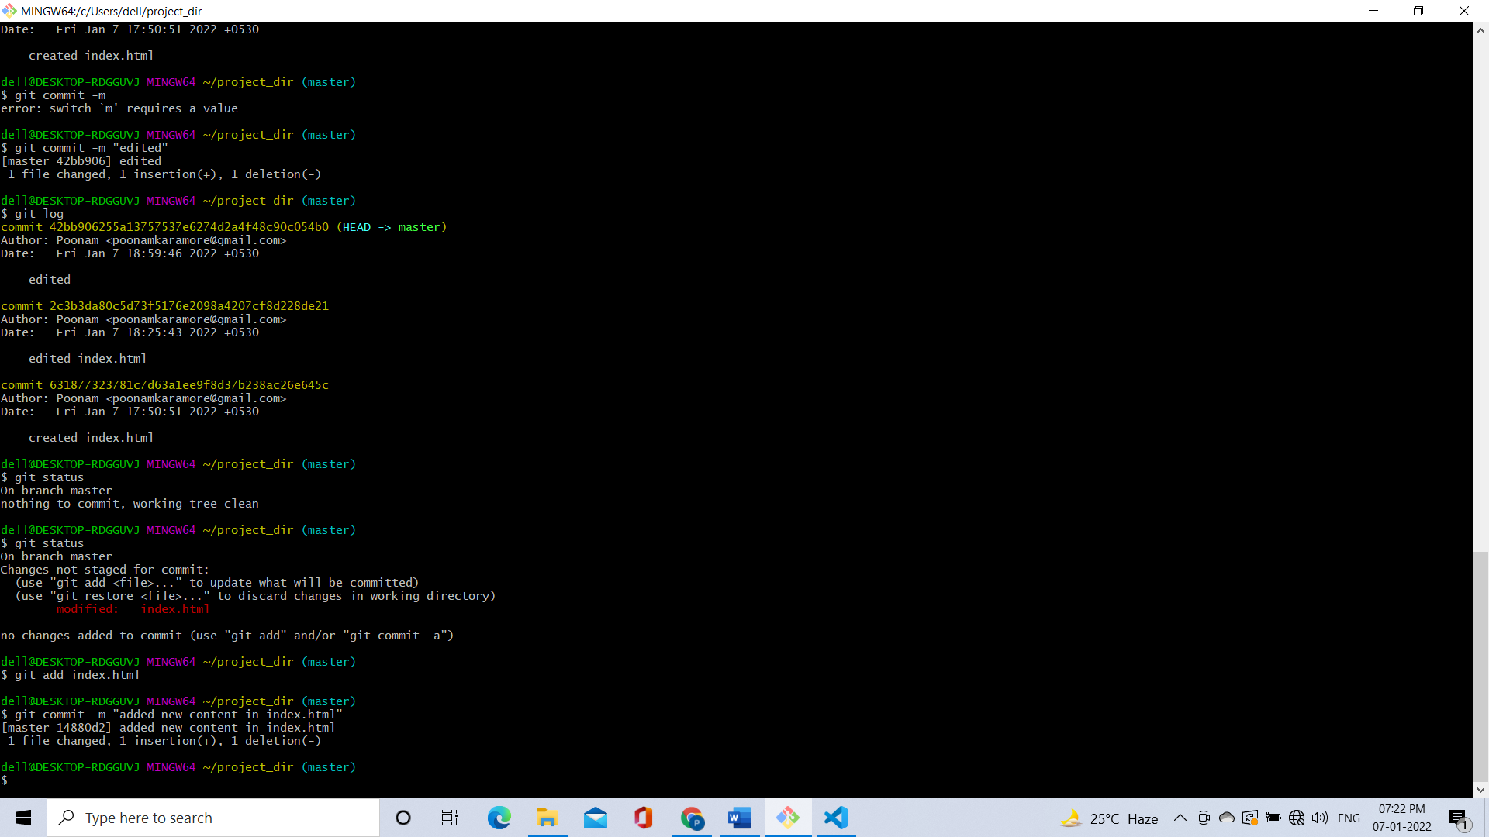

14. Revert the change made in the previous step using git command.

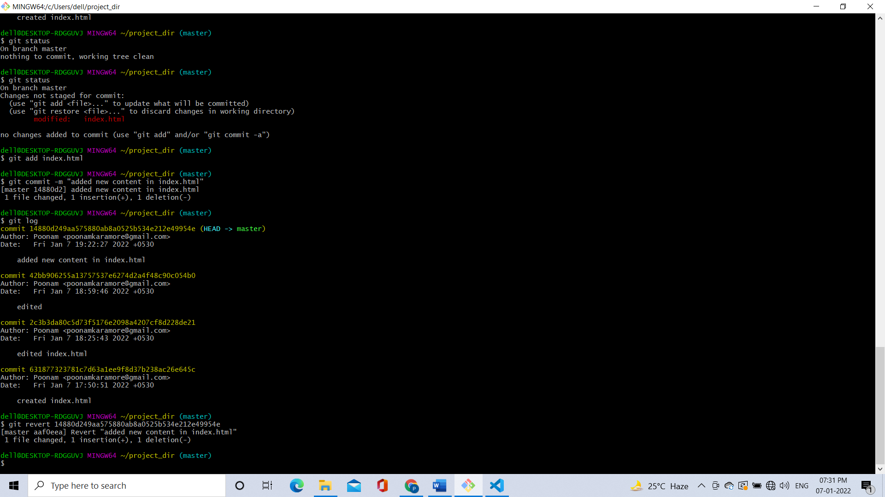

15. Again change index.html.

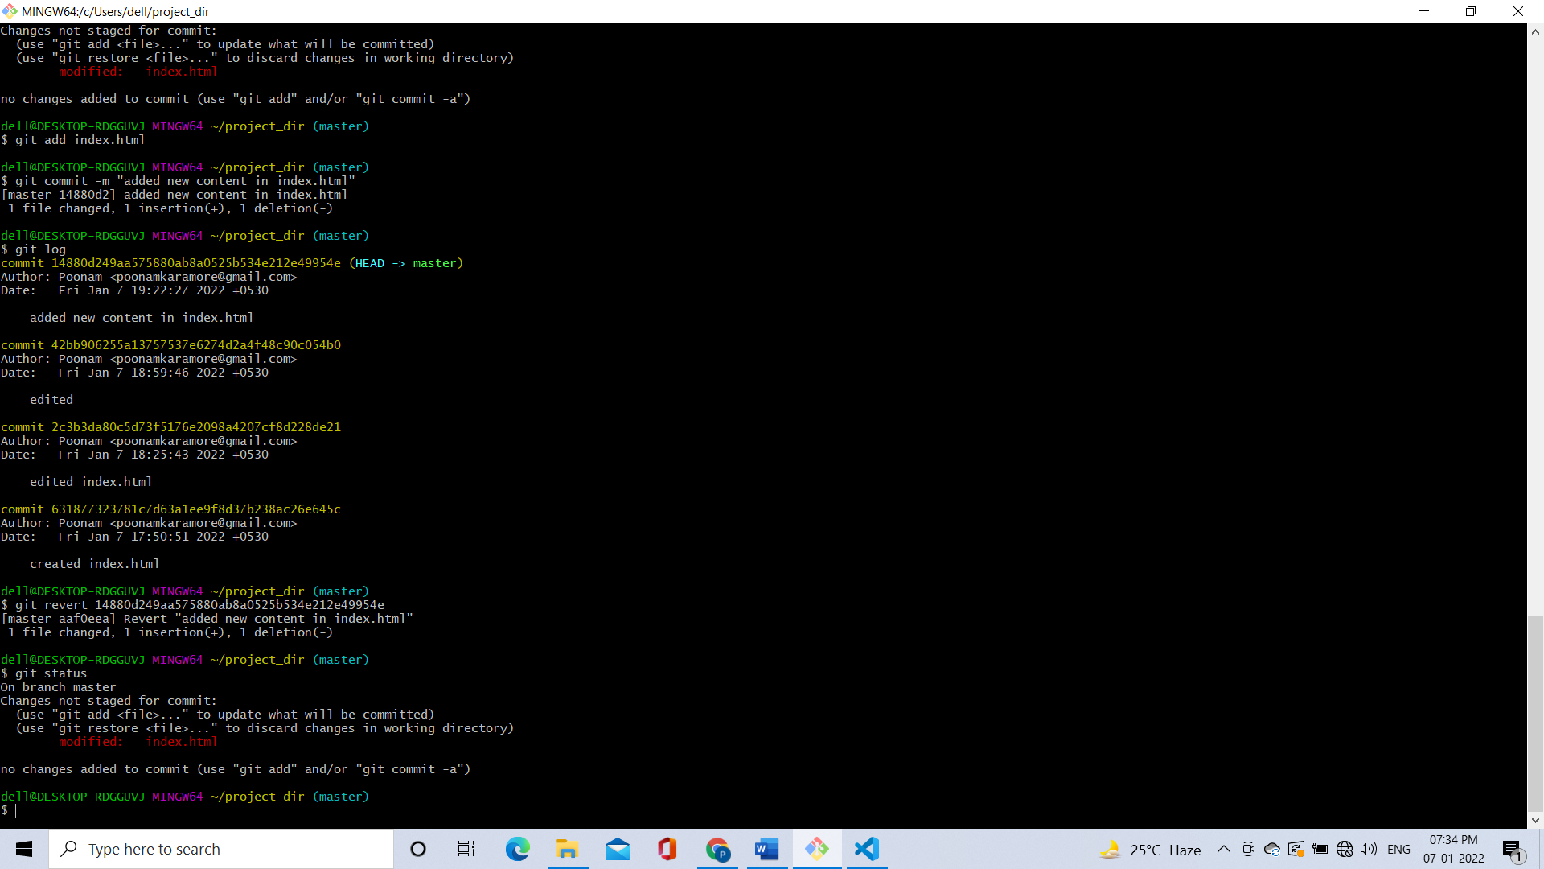

16. Stage index.html

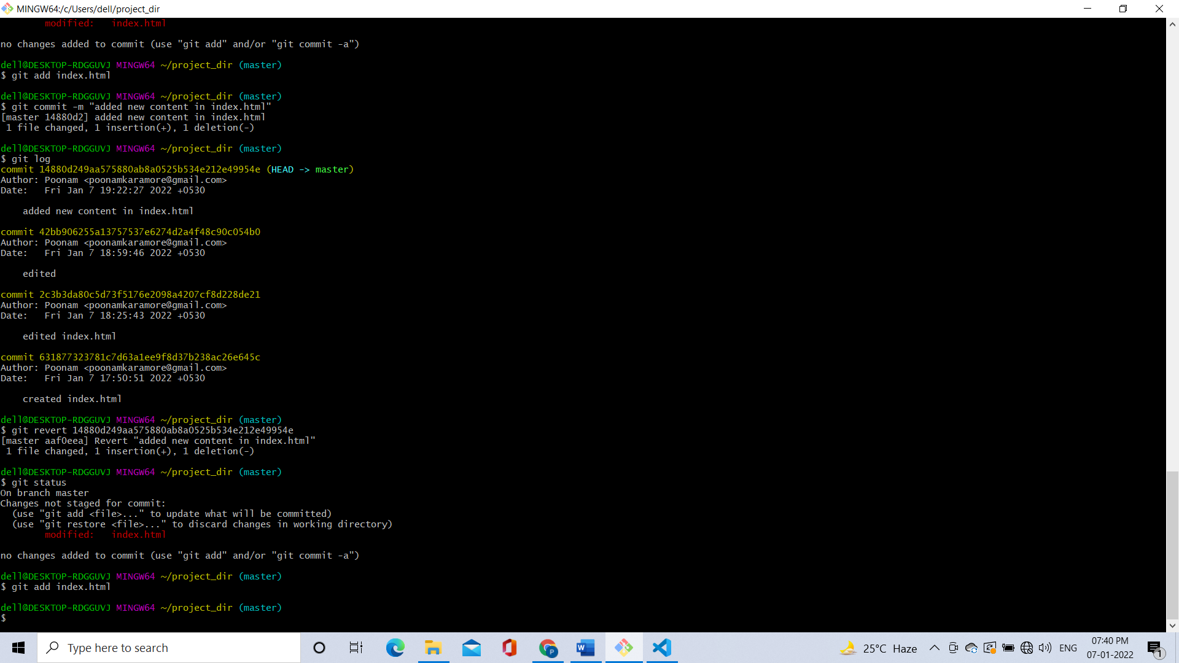

17. Revert back the last stage

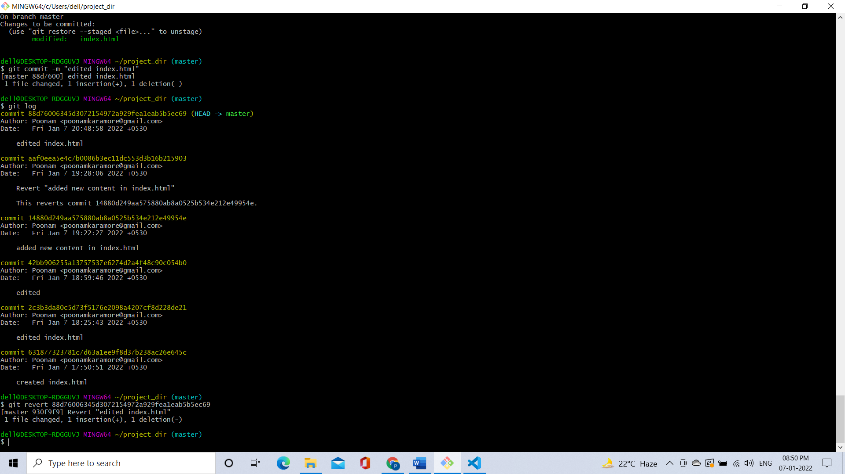

18. Rename ‘add’ command to ‘my-add’

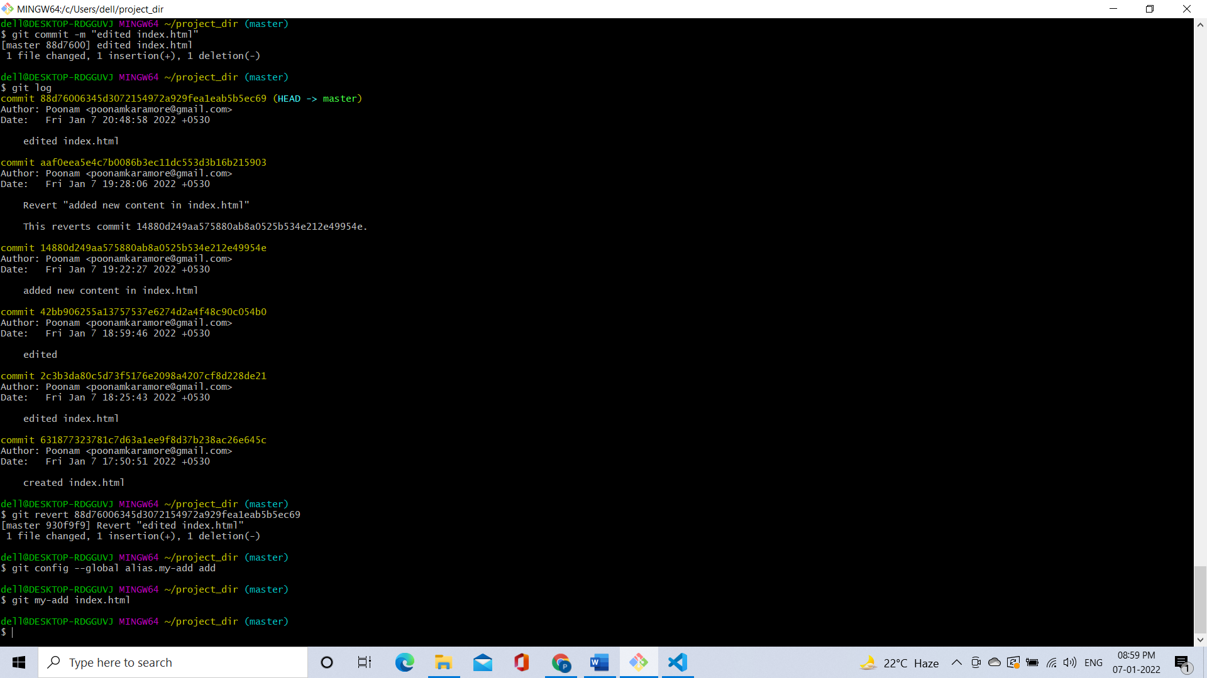

19. Using my_add command Stage index.html again & commit the changes.

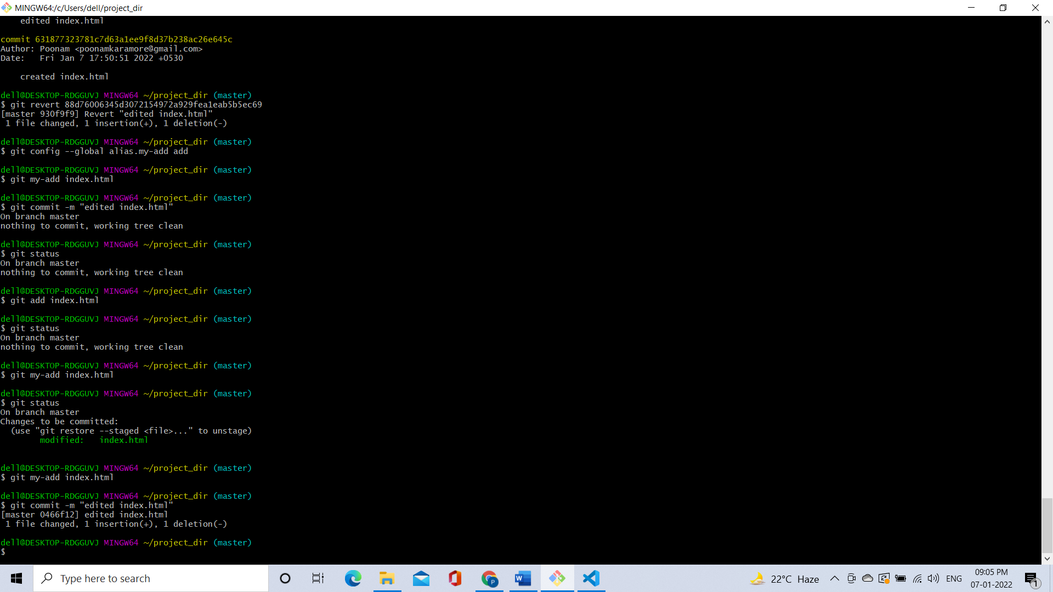

20. Revert the last commit

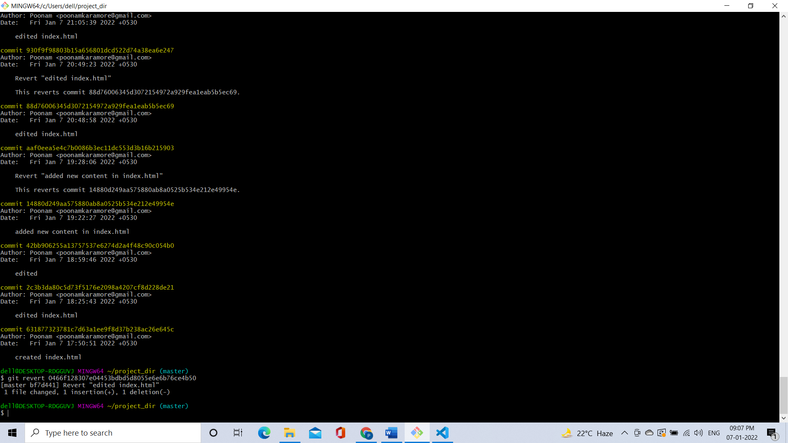

**GIT BRANCHING**

**SECTION-1 (HTML assignments) - Steps to follow:**

22. Create an empty directory ‘Assignments’ & cd to ‘Assignments’.

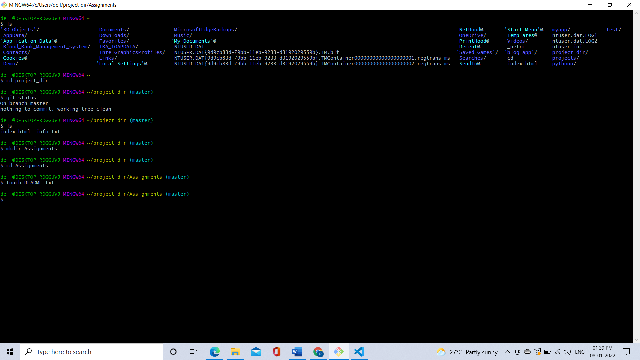

23. Create a file README.txt inside ‘Assignments’ & write few lines about the contents of ‘Assignments’ folder.

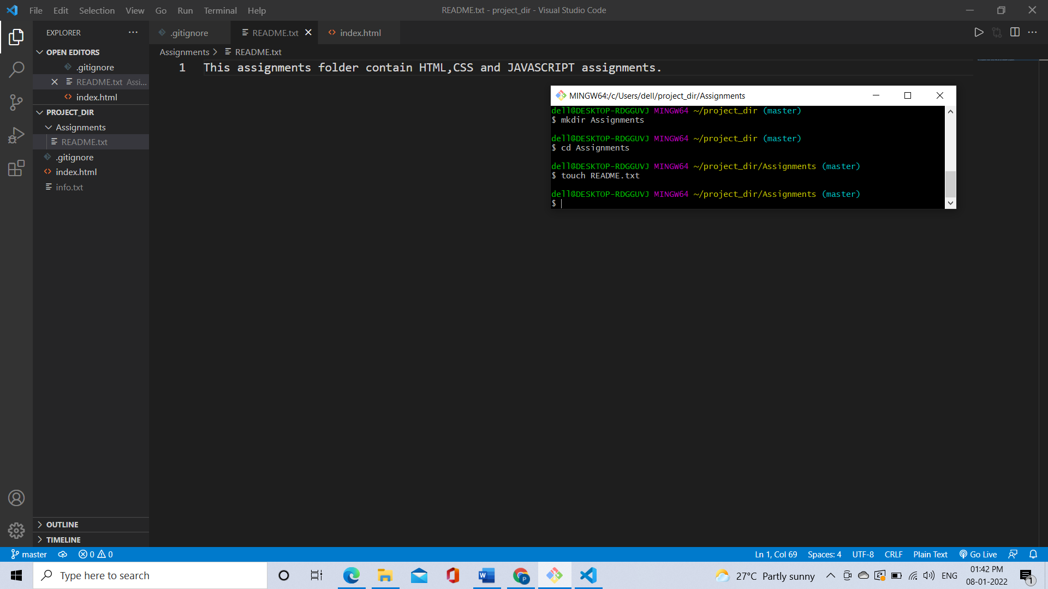

24. Commit README.txt file.

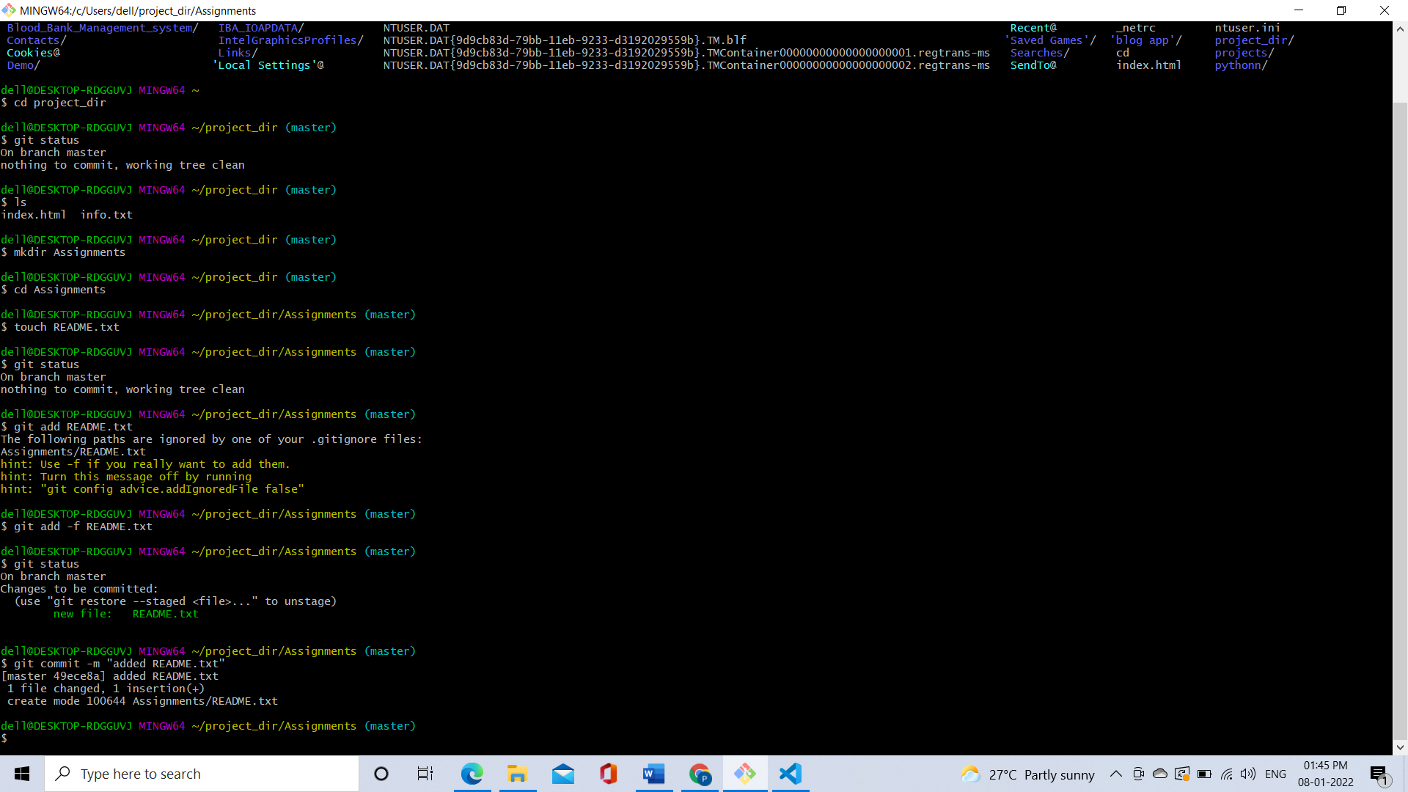

25. Now create a new branch ‘html-assignments’.

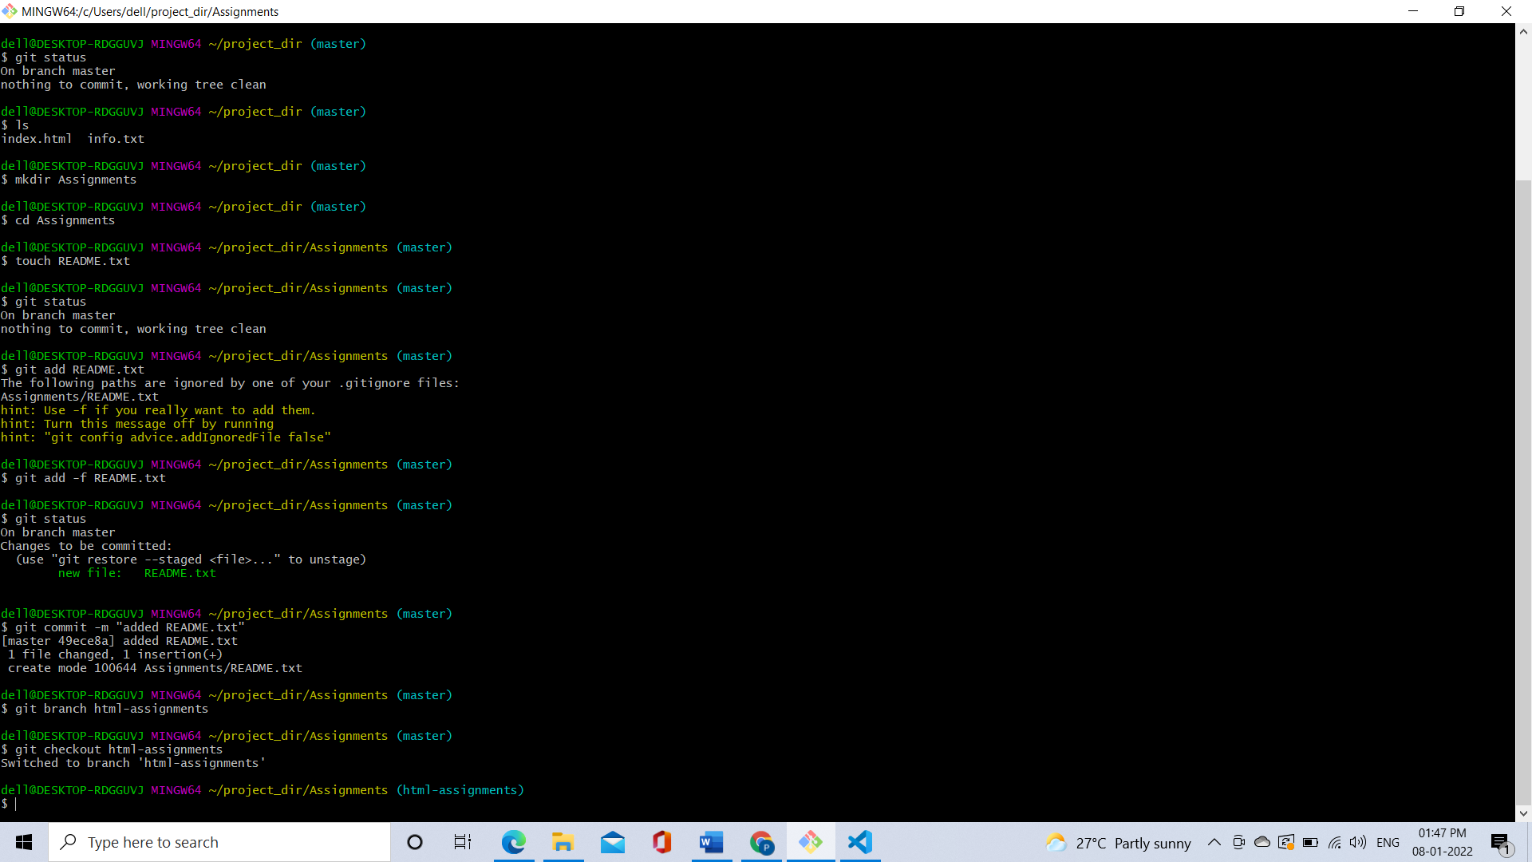

26. Switch to ‘html-assignments’ branch.



27. Copy all HTML assignments inside ‘Assignments’ folder.

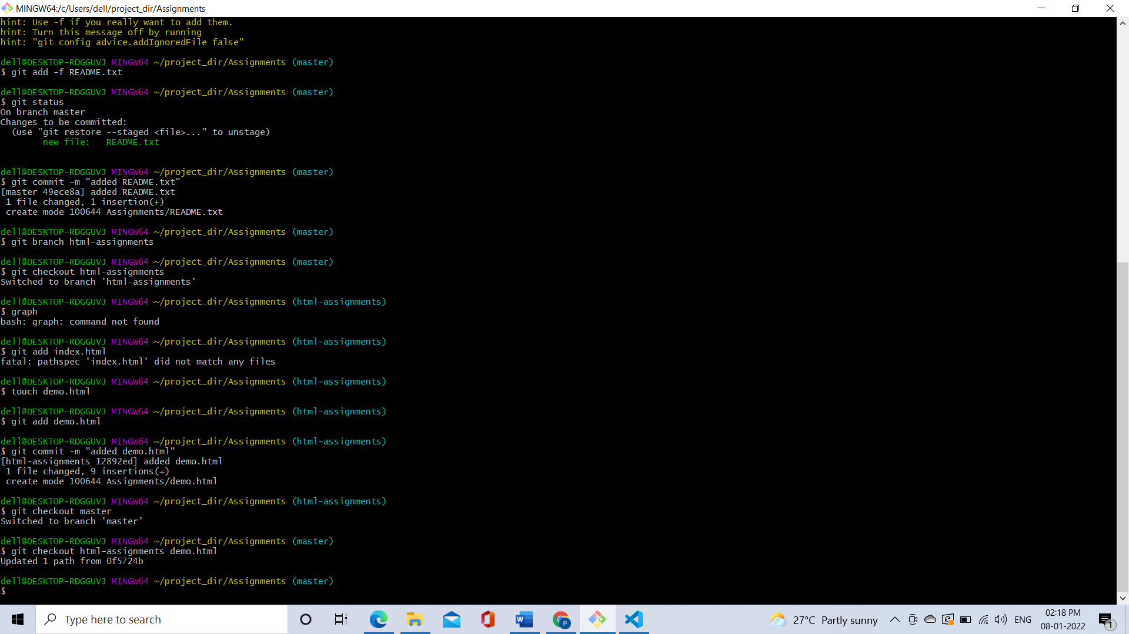

28. Commit HTML assignments into ‘html-assignments’ branch.



29. Make minor changes into few files belonging to ‘html-assignments’ branch.

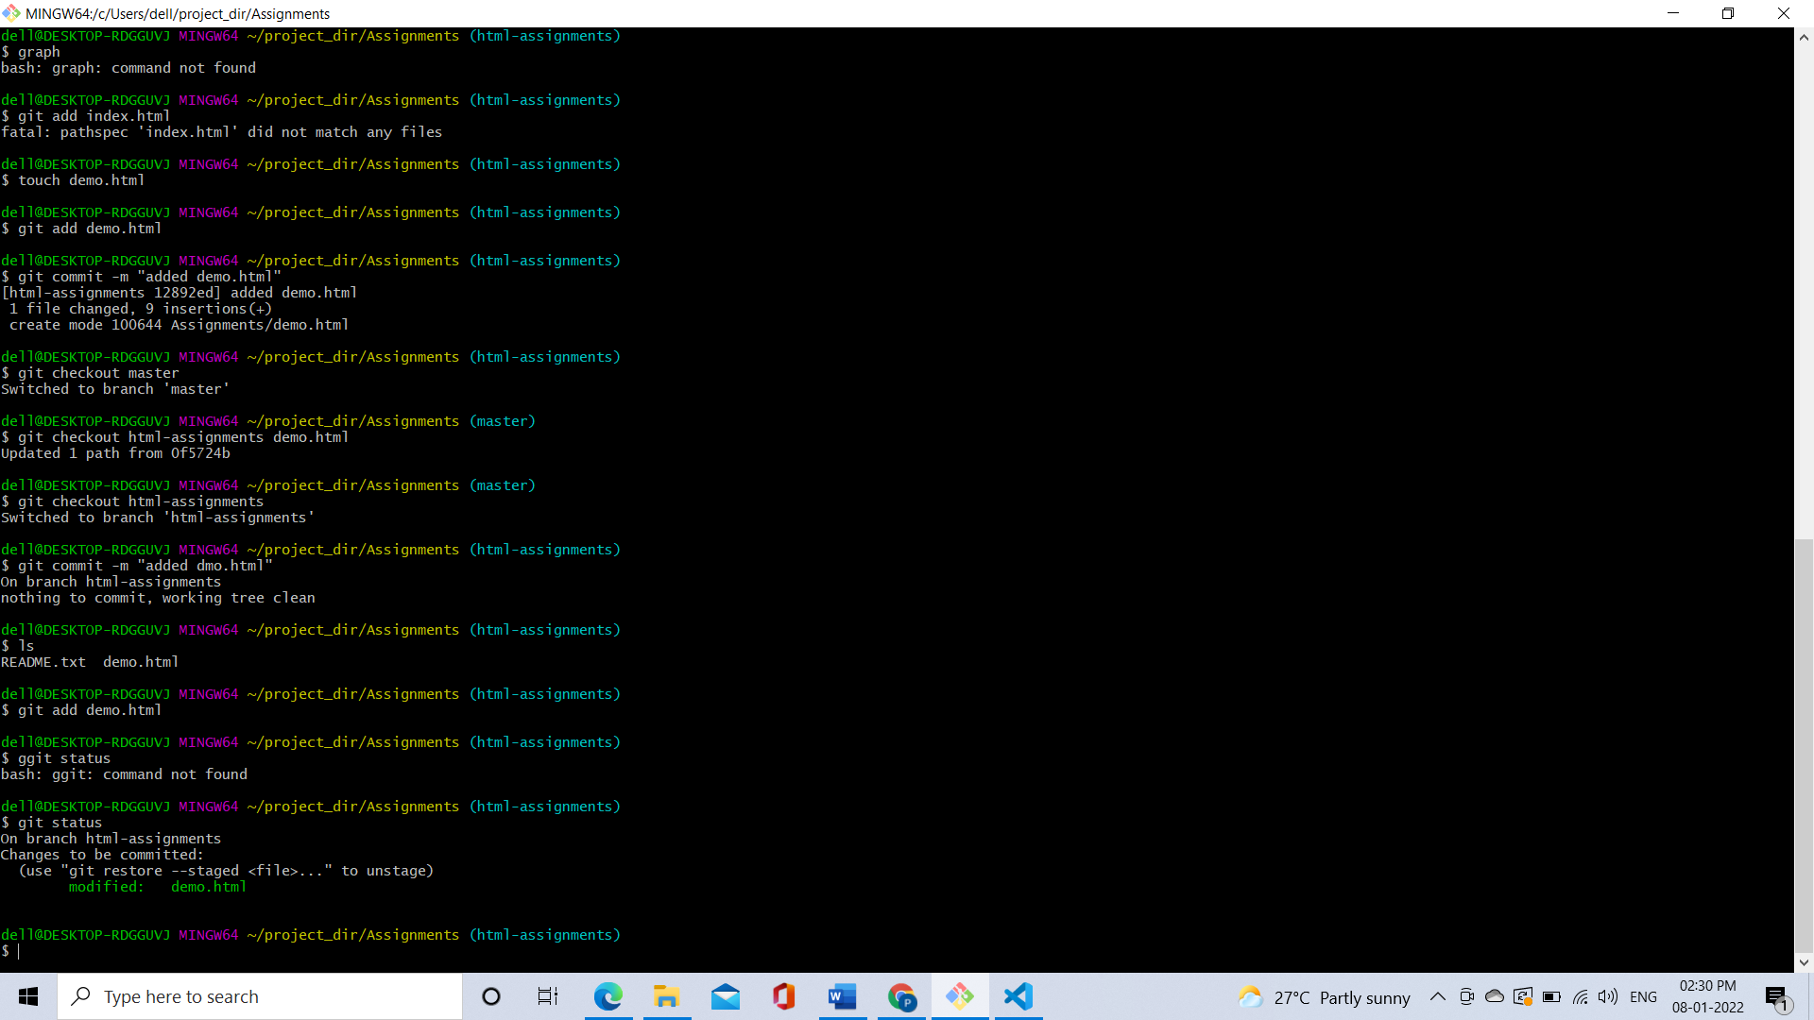

Old file New file

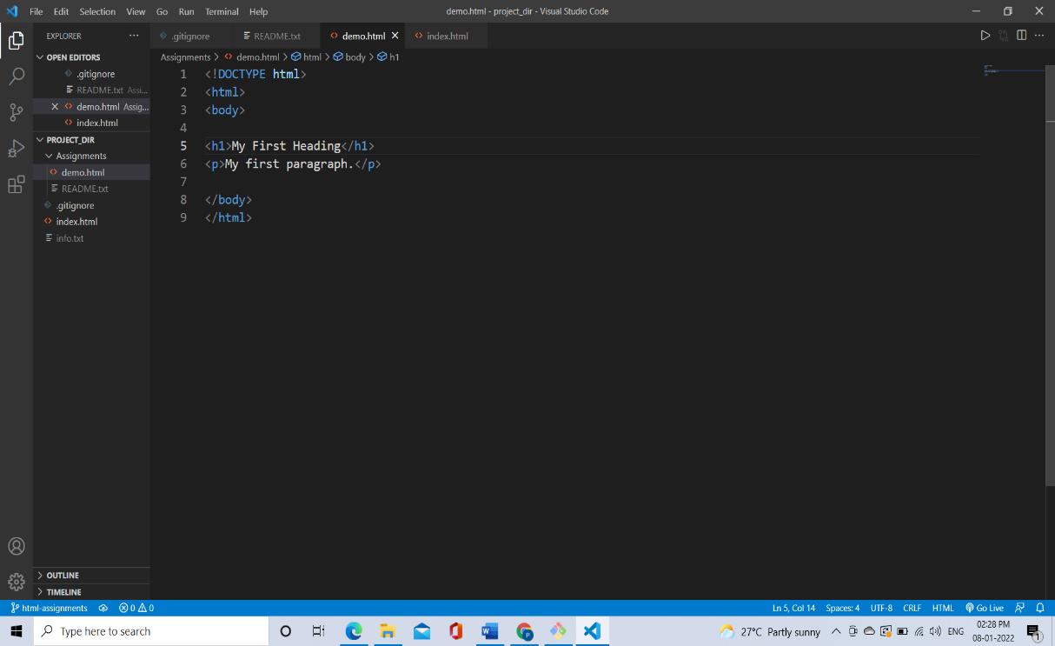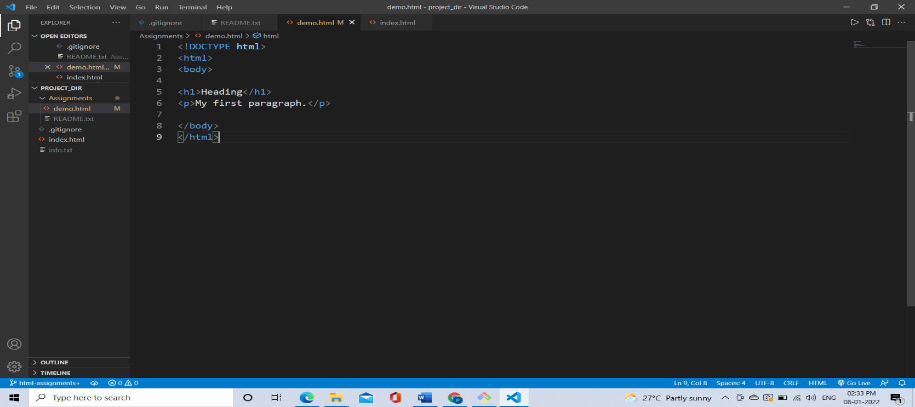

30. Commit those changed files.

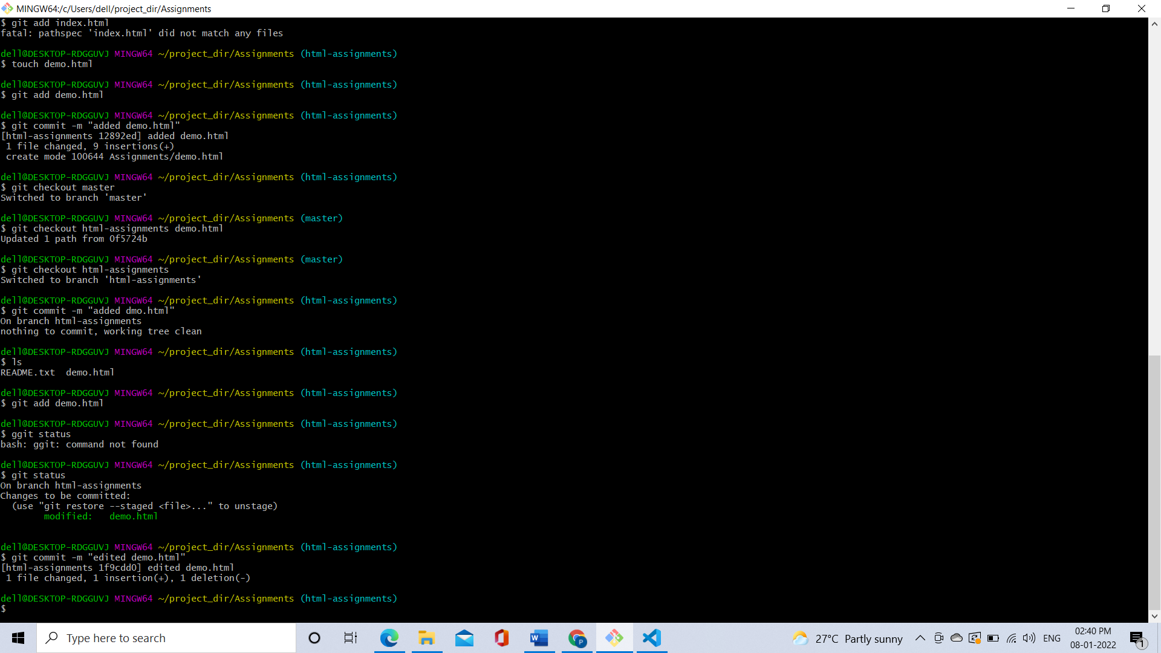

31. Switch to master branch.

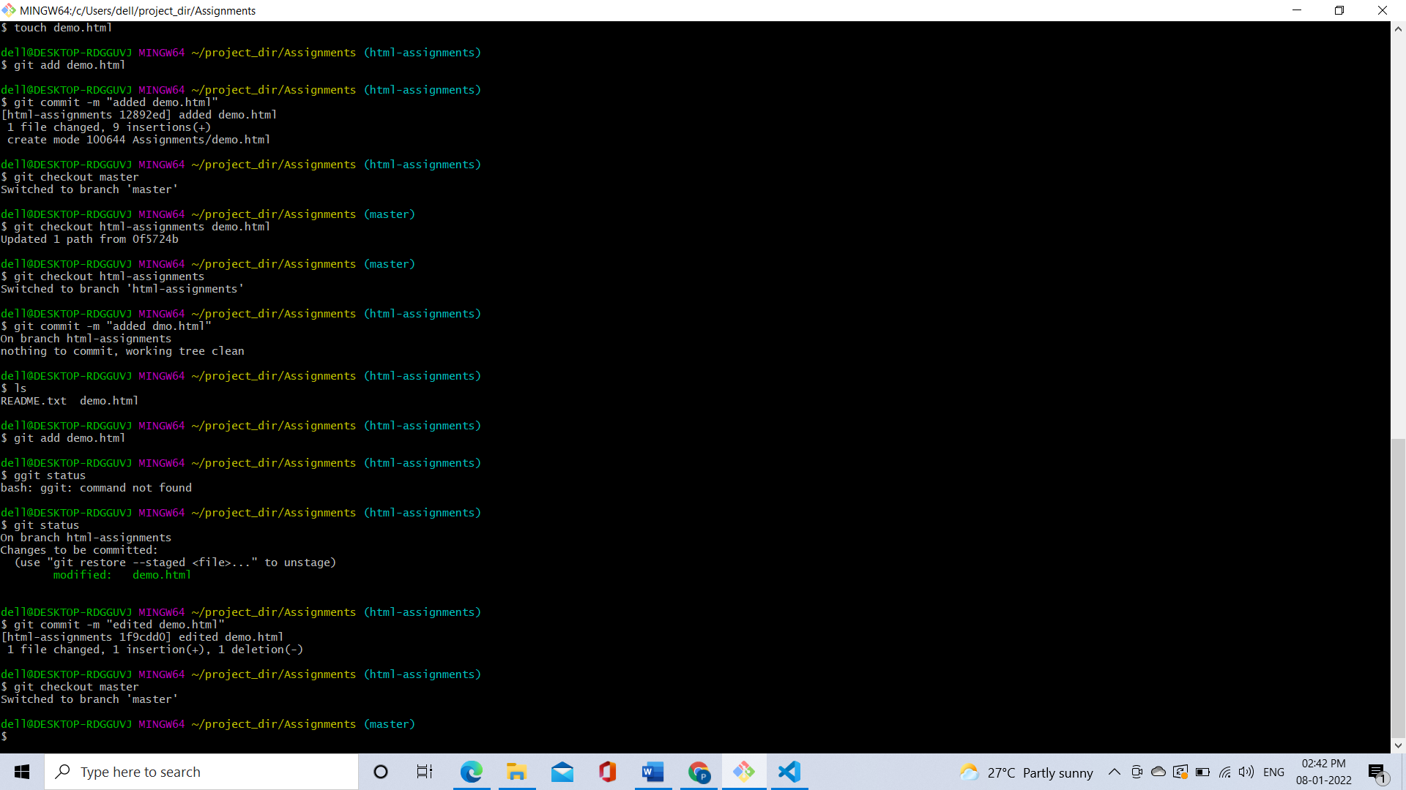

32. Make minor changes into README.txt file & commit those changes into master.

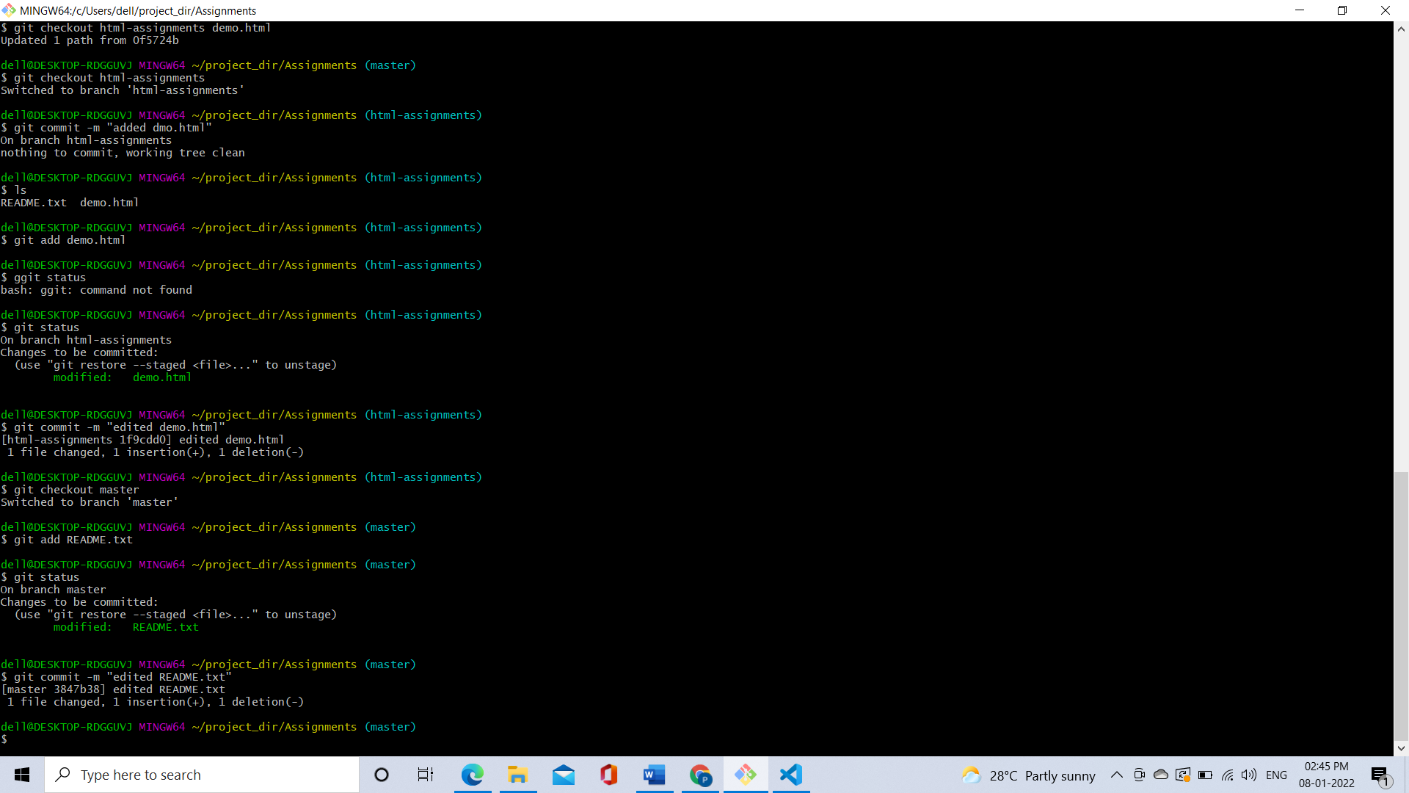

33. Again switch to ‘html-assignments’ branch.

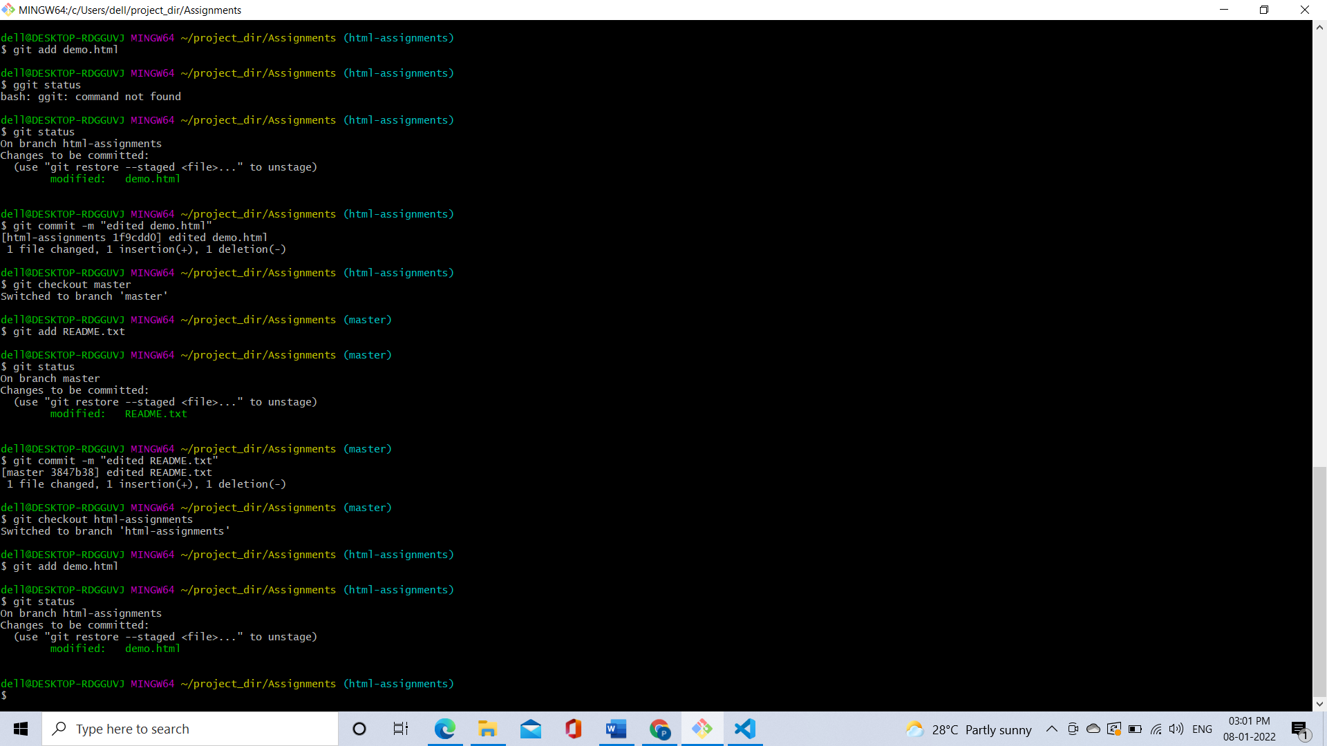

34. Make minor changes into few files belonging to ‘html-assignments’ branch.

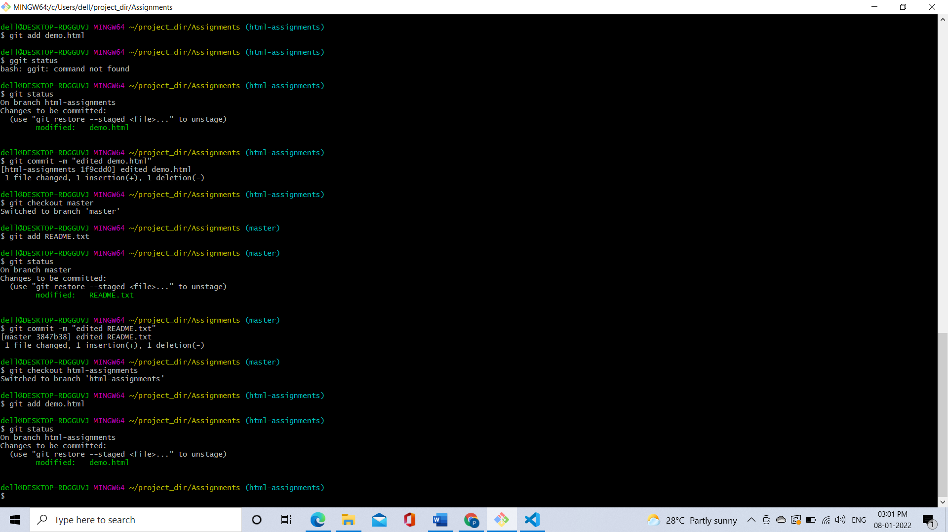

35. Commit those changes

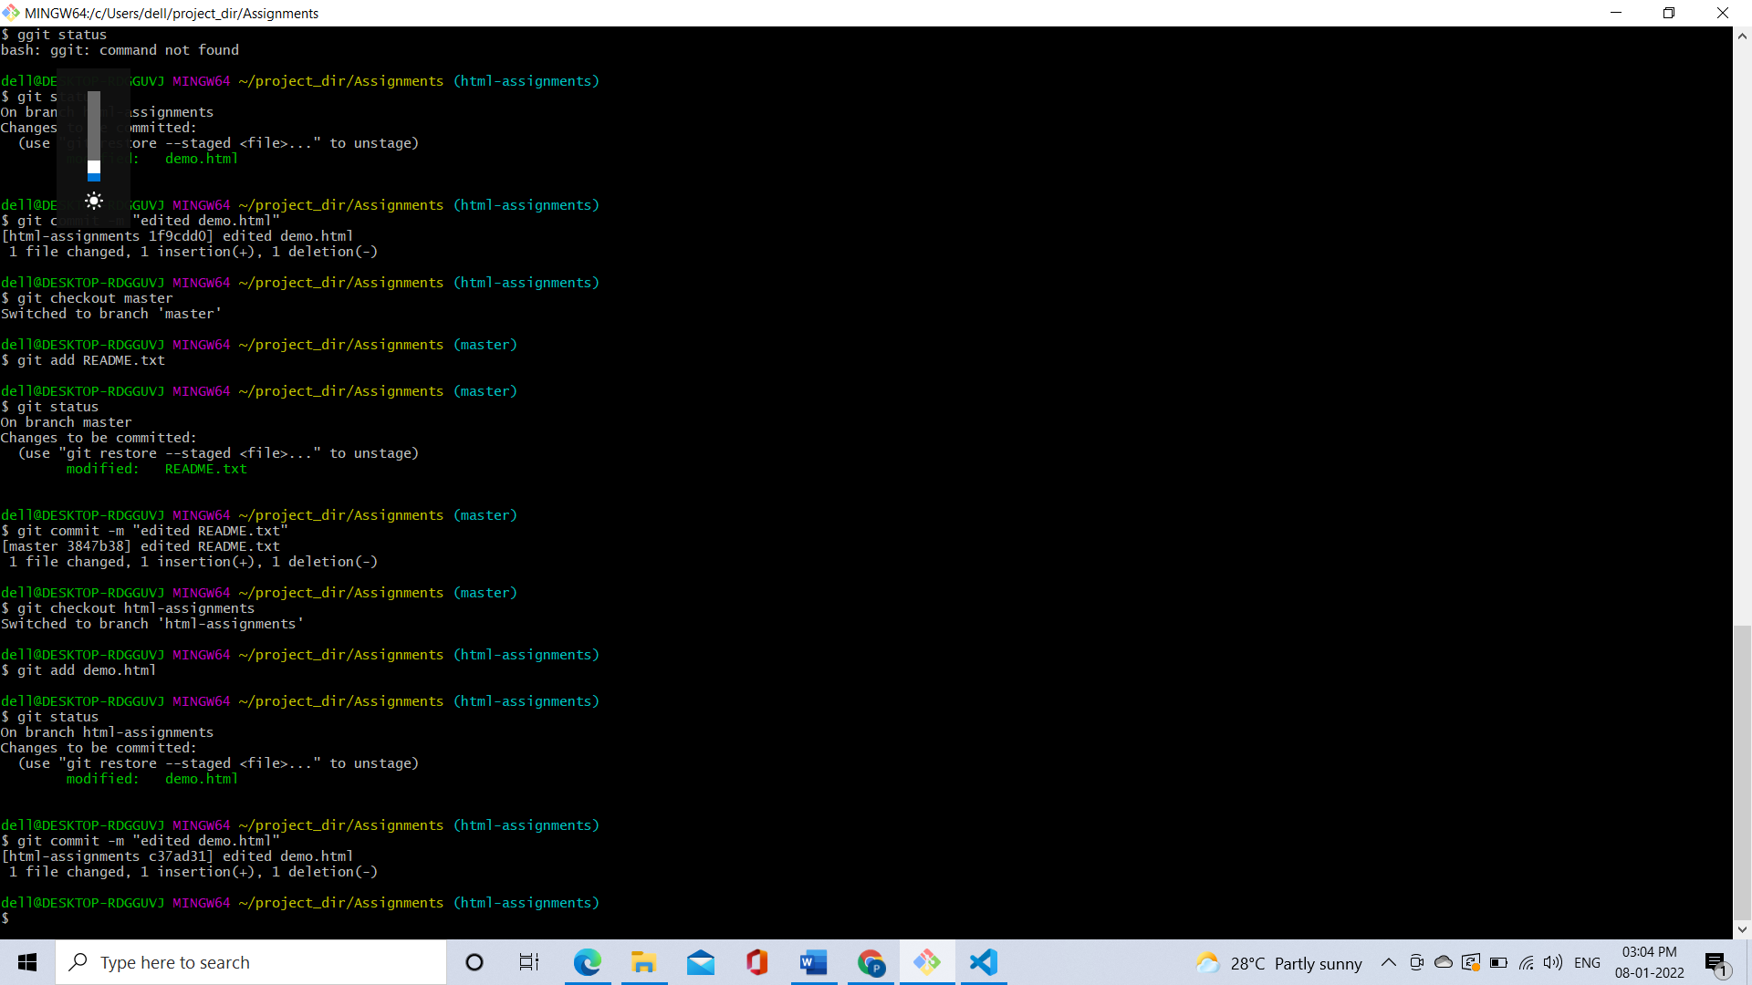

36. Switch to master.

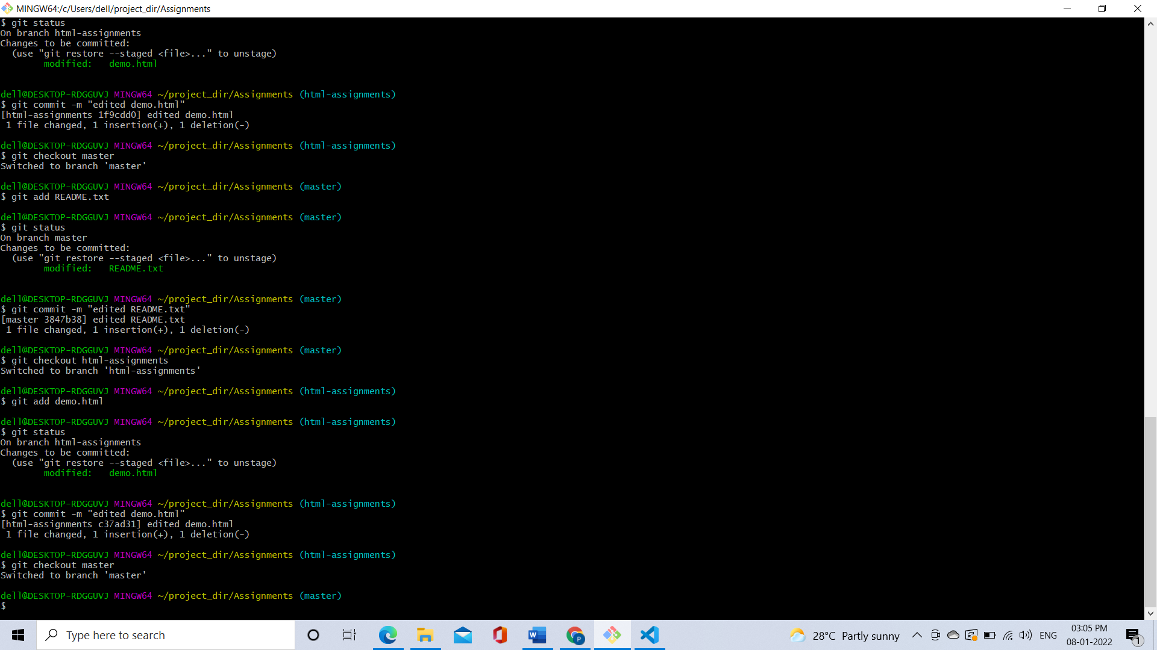

37. Merge ‘html-assignments’ branch into master. Confirm all html assignments are shown in master.

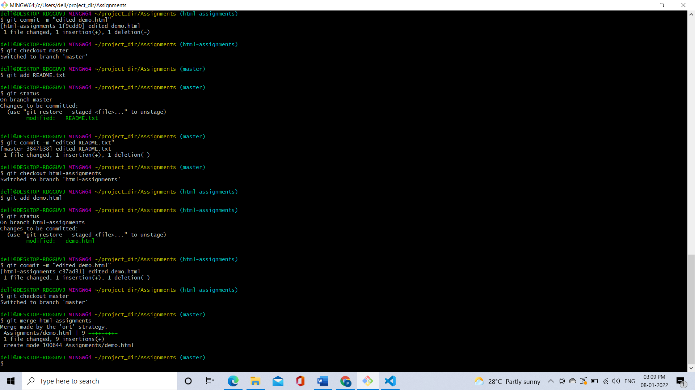

38. Finally delete the ‘html-assignments’ branch.

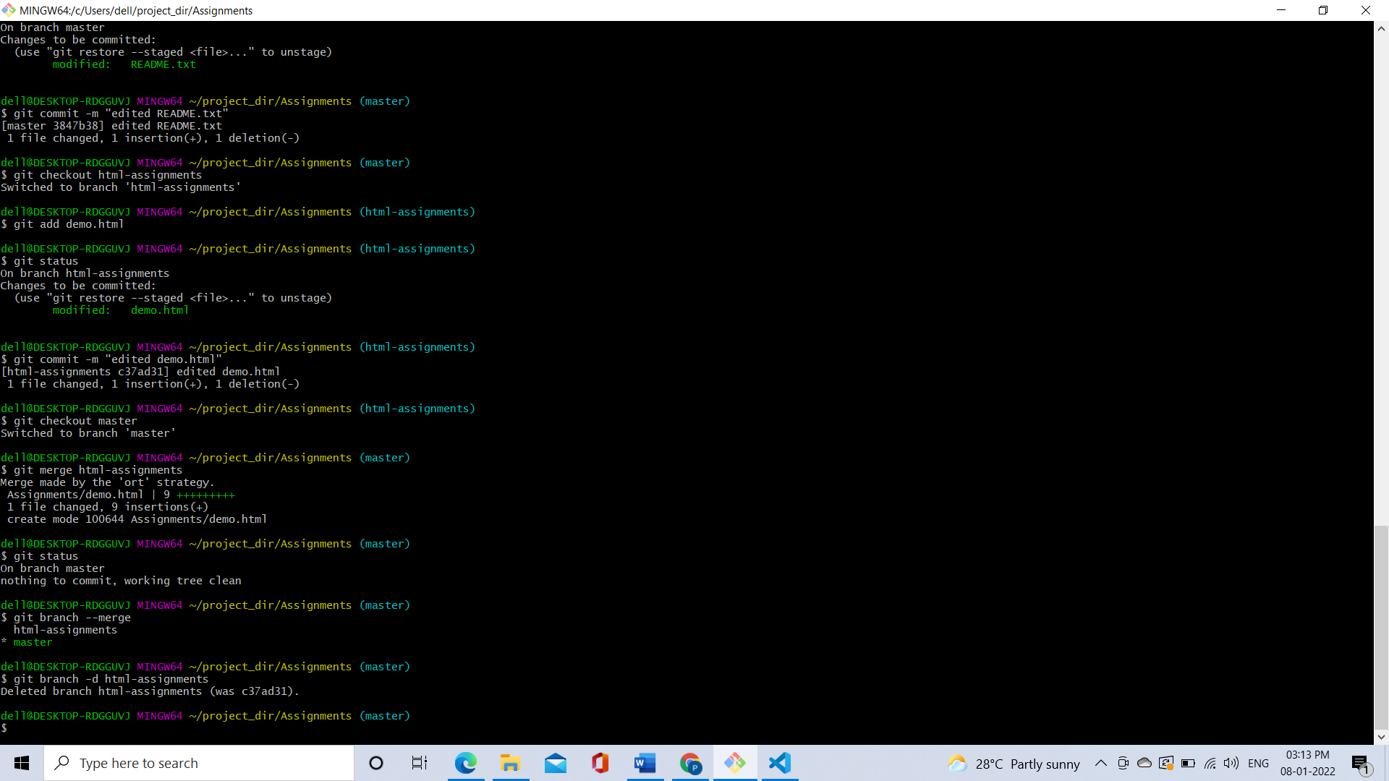

**SECTION-2 - (CSS assignments) Steps to follow:**

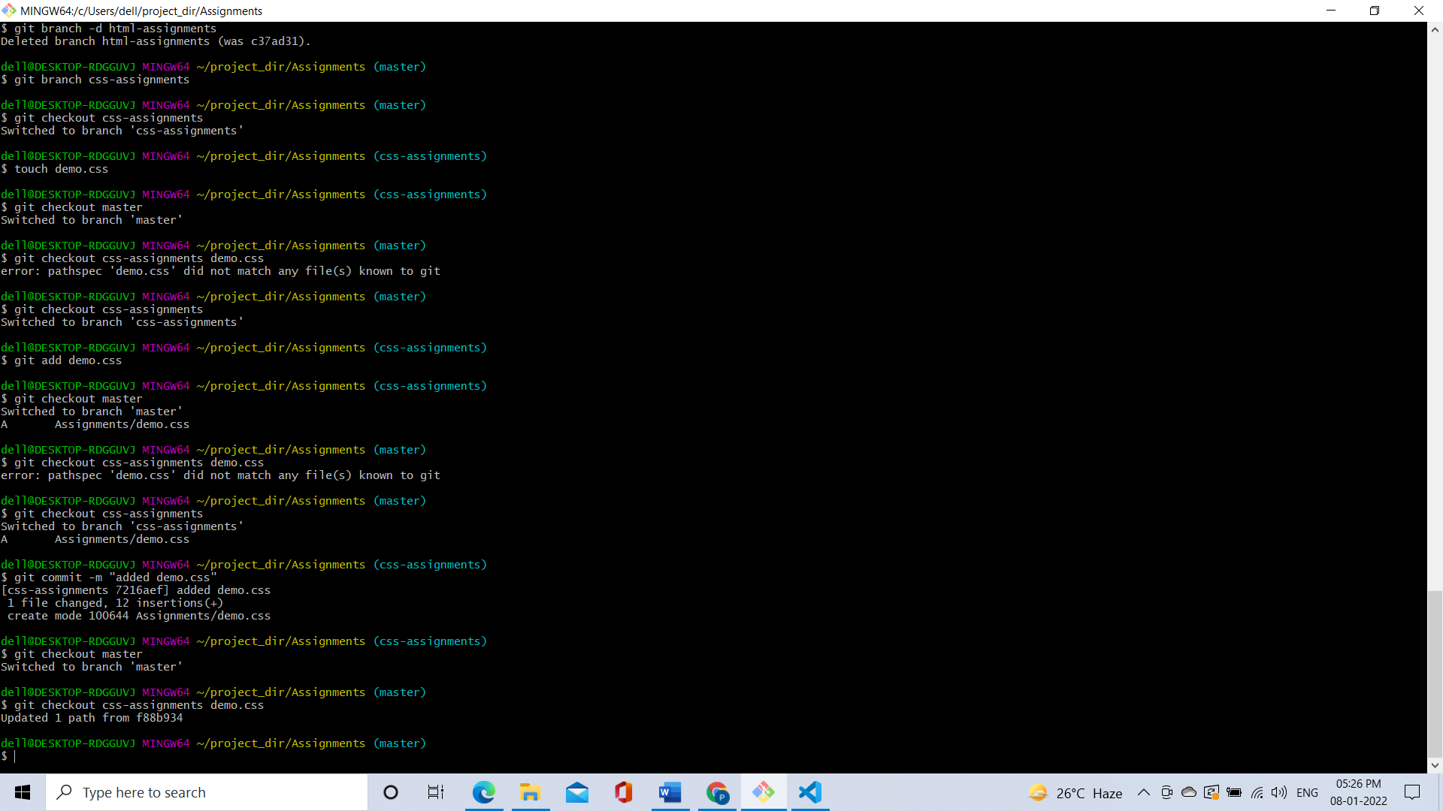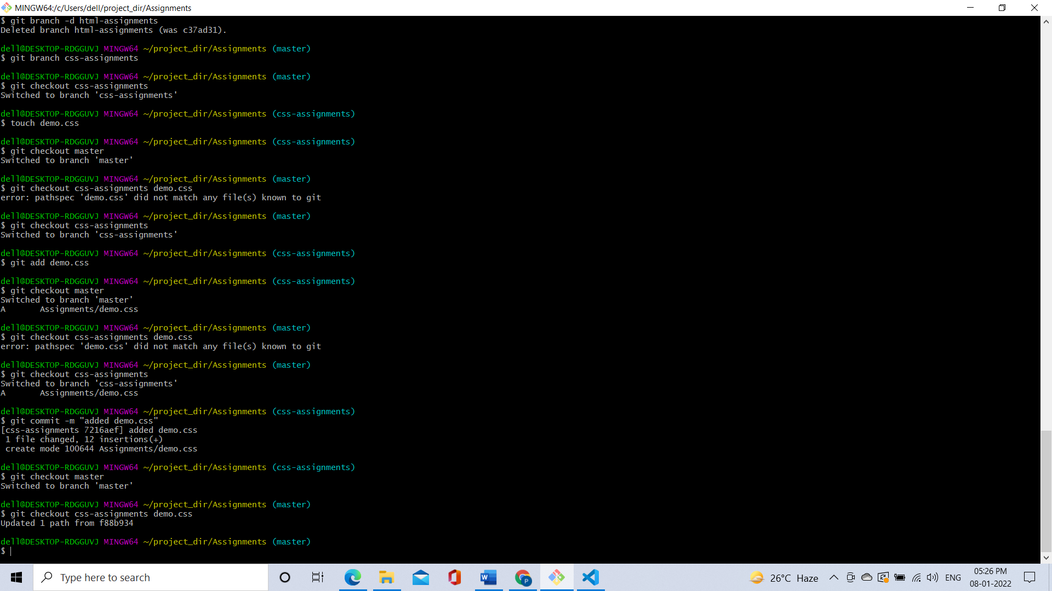

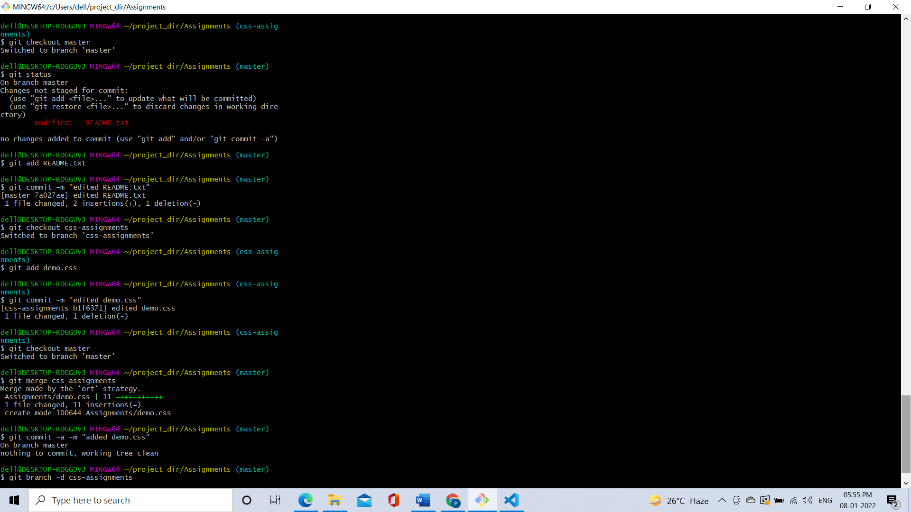

**SECTION-3 - (JavaScript assignments) Steps to follow:**

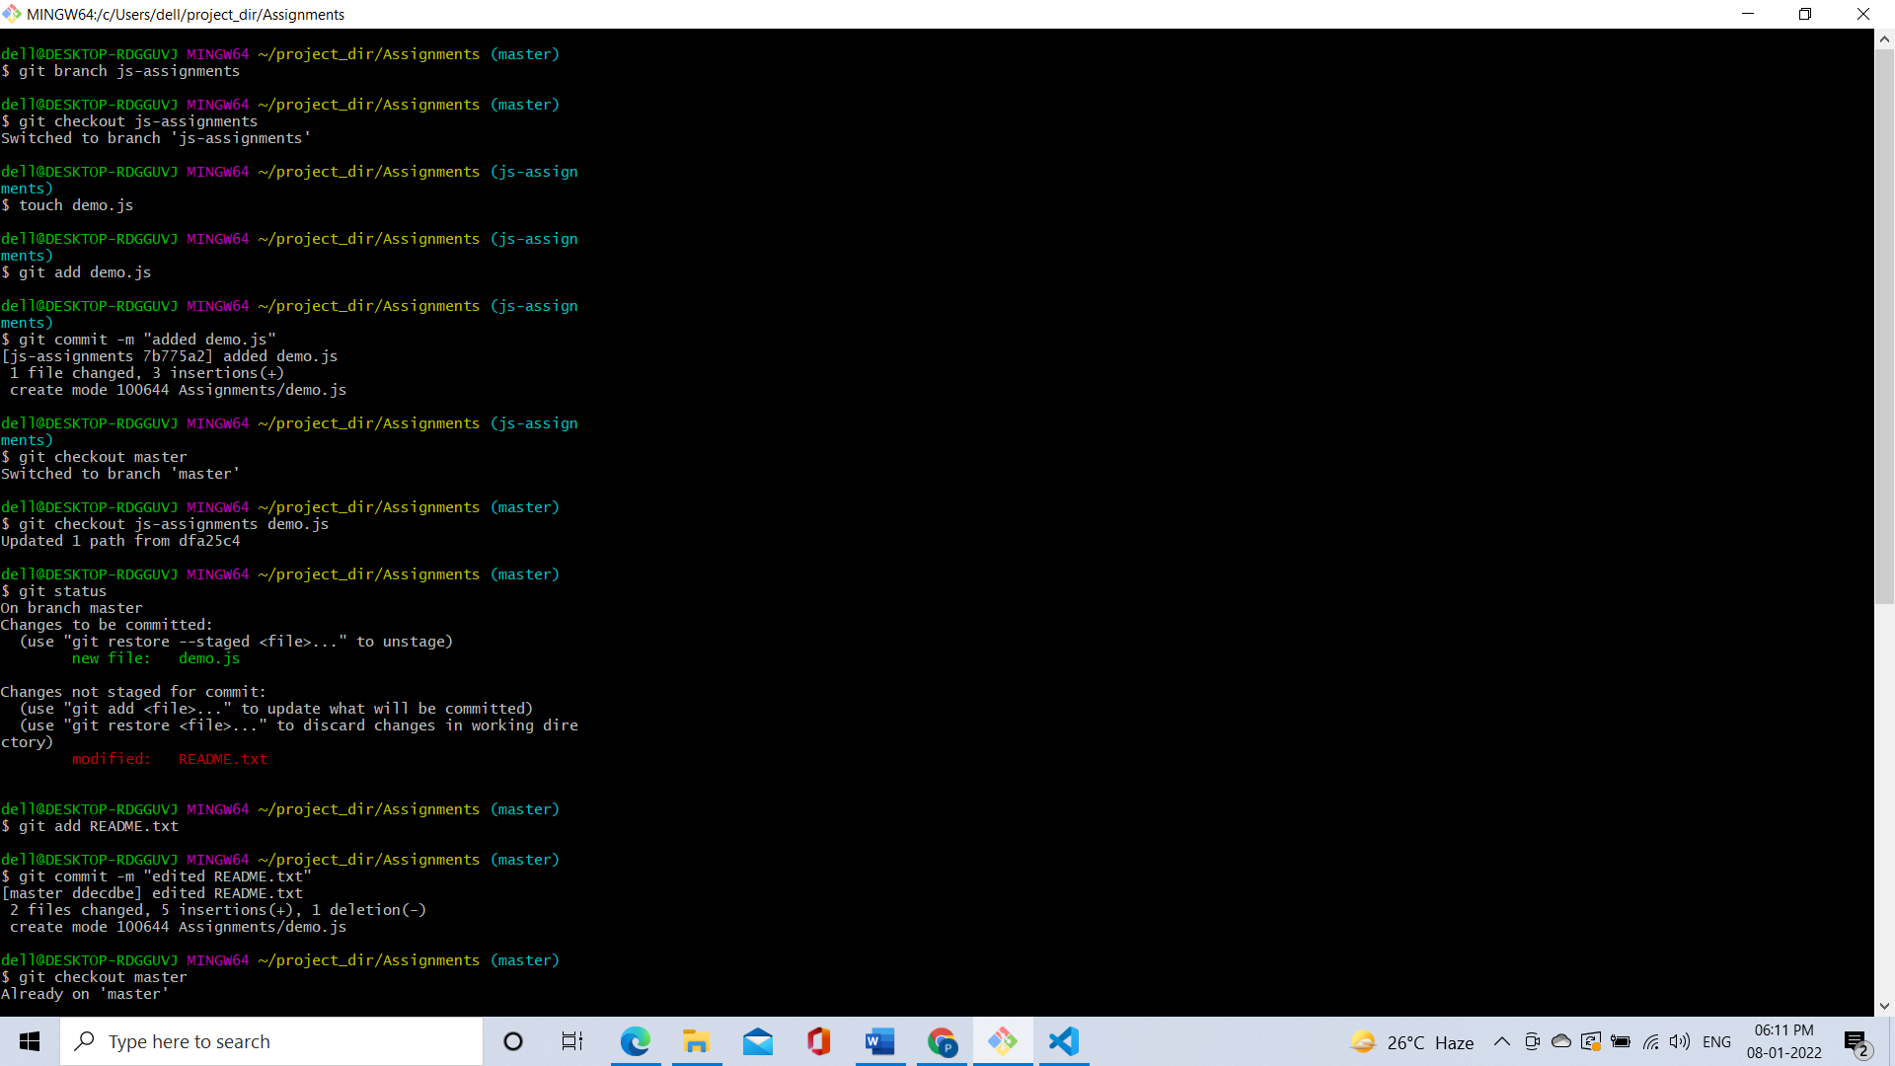

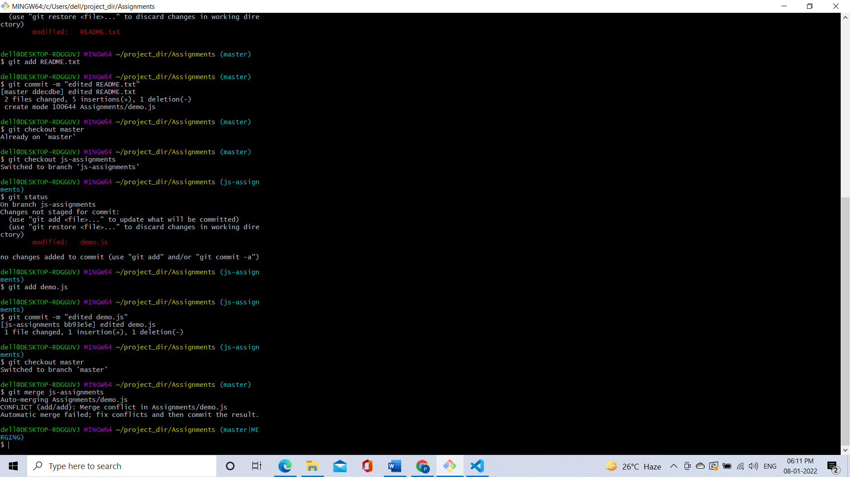

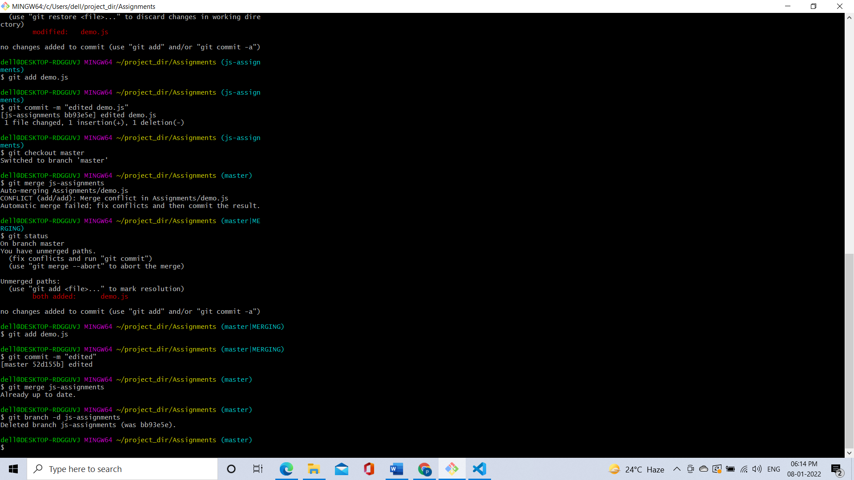

**GIT Remoting**

SECTION-1 (Pushing assignments to remote repository) - Steps to follow:

